Market Timing Tactical Asset Allocation

INSEAD Masters in Finance (MFIN17M) – Capstone Project

**Cameron Allan McLean**  
cameron.mclean@insead.edu

March 2017

ABSTRACT

[write once finished]

Copyright Cameron Allan McLean

Contents

List of Figures and Tables 3

Introduction 4

Replication of A Quantitative Approach to Tactical Asset Allocation 4

Summary of the paper 4

Data used 4

Strategy Performance Measurement 5

Asset returns including data 2013-2016 6

Replication of Global Tactical Asset Allocation including 2013-2016 7

Analysis of performance 9

Diversification and Modern Portfolio Theory 9

Recent Performance and the Financialisation of Commodities 11

Performance under rising interest rates 15

Practical and behavioural implications for Trend Following Investors 19

Improving returns 19

Diversification of assets 19

Avoiding Whipsaws 20

Delayed entry 21

Timing Band 23

Strategy Diversification 25

A Quantitative Approach to Tactical Asset Allocation in South Africa 28

Data 28

South African Asset Class Returns excluding Real Estate (1971-2016) 29

Timing Signal 29

JALSH – South African Domestic Equities 30

MSCI WORLD – Foreign Developed Equities (in local currency ZAR) 31

SA10YR 32

GSCI – Commodities Index (in local currency ZAR) 33

Systematic Tactical Asset Allocation South Africa (1972-2016) 35

South African Asset Class Returns including Real Estate (1994-2016) 37

JSAPY – South African Real Estate Index 38

Systematic Tactical Asset Allocation South Africa (1994-2016) 39

Comparison to South African funds 41

Conclusion 43

Appendix 1 – Data validity check 44

Appendix 2 – Review of R 45

References 46

# List of Figures and Tables

Figure 1 - Performance Measures 5

Figure 2 - Asset Class Returns 1973-2016, Log Scale 6

Figure 3 - Asset Class Returns 2012-2016, Non Log Scale 7

Table 4 - Asset Class Returns 1973-2012 7

Table 5 - Asset Class returns 1973-2016 7

# Introduction

[write once finished]

# Replication of A Quantitative Approach to Tactical Asset Allocation

## Summary of the paper

In July 2006, Mebane Faber began to circulate a working paper entitled A Quantitative Approach to Tactical Asset Allocation which was subsequently published by The Journal of Wealth Management in Spring 2007. In February 2009 Faber updated his paper to include data from 2006-2008 and then again updated the paper in February 2013 to include data from 2009-2012 as well as test the approach on alternative asset classes and allocations.

The purpose of Faber’s research was “to present a simple quantitative method that improves risk adjusted returns across various asset classes” (Faber 2013). Testing over 5 asset classes from 1973-2012, his approach improved risk adjusted returns in every asset class tested and when applied to an equal weighted asset allocation, resulted in equity like returns with bond like volatility and drawdowns.

The quantitative system used by Faber is based on one of the most well known trend following strategies commonly used by CTAs which uses a 200 day moving average to signal when to be long or move to safety. It met his criteria of being a simple, mechanical price based signal with non optimised parameters for all asset classes. Faber, testing with monthly data, adapted his approach to use the monthly equivalent 10 month simple moving average to signal when to get long or move to cash. The rules were simple; buy when the monthly price is greater than the 10 month simple moving average and sell and move to cash when the monthly price crossed below the 10 month simple moving average.

When applied to individual asset classes, the timing system consistently resulted in improved absolute returns, risk adjusted returns and max drawdowns. On average between 1973-2008 the timing system “increased returns by approximately 20%, decreased volatility by 20%, improved the Sharpe Ratio by 0.20 and reduced the maximum drawdown by nearly 50%” (Faber, 2009).

The results showed the simple moving average based market timing system could also be applied to global tactical asset allocation to significant improve the performance and risk metrics compared to a standard buy and hold strategy. The timing system had better absolute returns of 10.48% (vs 9.92% for the buy and hold), lower volatility of 6.99% (vs 10.28%) resulting in an improved Sharpe ratio of 0.73 (vs 0.43). Crucially for investors, the max drawdown of the timing model was only -9.54% (vs -46.00%) meaning that investors never experienced the pain of giving back more than 10% of their equity. Lastly in the 40 years of data between 1973-2012, the timing strategy remarkably only had 1 year of negative performance, which was a respectable -0.59%.

## Data used

Faber applied his quantitative approach to five asset classes – Domestic (US Large Cap) Equities, Foreign Developed Equities, US Bonds, Commodities and Real Estate. He chose publicly traded indices representing these asset classes and obtained monthly total return data series from Global Financial Data to use in his framework. The actual indices chosen were Standard and Poor’s 500 Index (S&P 500), Morgan Stanley Capital International Developed Markets Index (MSCI EAFE), United States Government 10yr Treasure Bonds (US10YR), Goldman Sachs Commodity Index (GSCI) and the National Association of Real Estate Investment Trusts Index (NAREIT).

Global Financial Data is a paid data provider unwilling to make their data available for academic purposes. Data used in this paper has been obtained from a variety of sources. S&P500, NAREIT, EAFE, GSCI total return index data are available on Bloomberg. To represent Fixed Income, 10yr US Government Bond Yields were obtained from FRED and a total return index that takes into consideration both capital appreciation and income has been created following the methodology of Morningstar. A similar index was created using 3 month US Treasury Bond Yields to represent risk free returns. Overall differences in performance results are minimal and outlined in appendix [X]. Although there are small discrepancies I am confident the datasets are close enough to the original data that the results in the paper are valid.

[put summary table similar to SA]

## Strategy Performance Measurement

Strategy performance analysis is commonly done using returns that have been somehow adjusted for risk. Simply looking at the return would be unfair (Ilmanen, 2011) as it ignores the volatility of the strategy and whether it is something that can realistically be handled by the investor (Clenow, 2013). In Faber’s Papers, he compares strategies by looking at the CAGR, Volatility, Sharpe Ratio, Max Drawdown and in some comparisons, he also includes the percentage of positive months as well as the growth of $100. Although the basic structure of all composite risk measures are the same, it is recommended that a few better understood measures are selected to give a fuller understanding of each strategy’s performance and risk (Bacon, 2004). In this paper the following measures have been included to analyse performance:

|  |  |  |
| --- | --- | --- |
| CAGR | % in the Market | Max Drawdown / CAGR |
| Volatility | % Positive Months | Sharpe Ratio |
| Skew | Best Month | Sortino Ratio |
| Kurtosis | Worst Month | MAR Ratio |
| Inflation CAGR | Max Drawdown | Ulcer Index |

Figure - Performance Measures

The Sharpe Ratio is one of the most commonly used and cited measures to compare strategies of different volatility and was the only risk adjusted return metric included in Faber’s paper. Originally developed by William Sharpe in 1966, the formula is simply the annualised return less the risk free return divided by the volatility of the return. One of the problems with the Sharpe Ratio is that is penalises all volatility whereas in some cases, such as when the strategy is making money on the upside, the investor may actually like and want volatility. As such the Sortino Ratio has been included as it only uses the volatility of negative returns and does not punish returns for moves in the right direction. The MAR ratio (or Calmar) is similar to the Sharpe Ratio although it adjusts returns by the maximum drawdown. It is traditional to use 3 years for the Calmar ratio, however here the MAR ratio is used which looks at the whole dataset. Max Drawdown / CAGR is a very similar metric that has also been included purely for its simplicity to illustrate to investors the magnitude of drawdowns relative to an average years returns. Developed by Peter Martin in 1987 the Ulcer Index has been included as another measure of downside risk. Suited for long only strategies, the ulcer index focuses on the length and severity of drawdowns and the worry caused to the investor – the higher a strategies ulcer index, the more likely it will cause sleepless nights or ulcers for the investor (Martin & McCann, 1989). Lastly skew and kurtosis have been included to give a more complete understanding of the return distribution. Strategies, such as those that sell out of the money put options, can have very consistent stable returns with very respectable Sharpe Ratios. However when markets move against them they are susceptible to rare but very large losses which can be identified with negative skewed fat kurtosis distributions.

## Asset returns including data 2013-2016

Faber first charts the asset class returns to see the routes they travelled from start to finish. The replication of this chart below and comparing it to Faber’s Figure 3 (page 16) between 1973-2012 visually confirms the data obtained closely matches the data Faber original used provided by Global Financial Data. Extending this chart to the end of 2016, we can see what has happened over the last 4 years of returns.

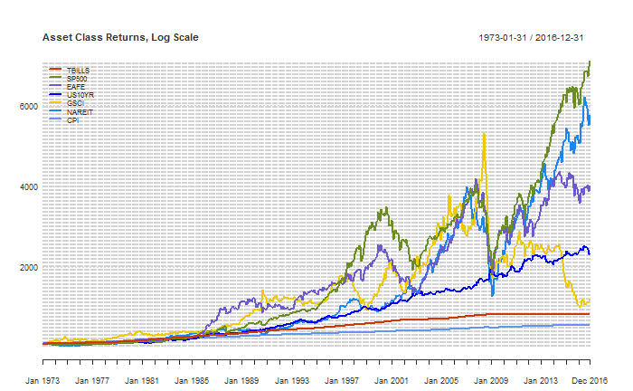

Figure - Asset Class Returns 1973-2016, Log Scale

It is clear to see most assets have continued to deliver positive returns however commodities (GSCI) have continued to underperform since it’s all time high in 2008. Zoomed in and rebasing at 2012 to confirm its much more obvious.

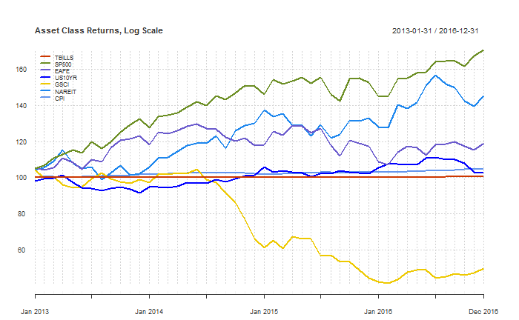

Figure - Asset Class Returns 2012-2016, Non Log Scale

Replicating performance statistics over the same set of asset classes we get very similar results to Faber’s research confirming the visual check above that the data used in both pieces of research is close to identical and accurate enough for our purposes.

|  |  |  |  |  |  |  |
| --- | --- | --- | --- | --- | --- | --- |
|  | TBILLS | SP500 | EAFE | US10YR | GSCI | NAREIT |
| Return | 5.42% | 9.77% | 9.19% | 8.12% | 8.34% | 9.64% |
| Volatility | 0.95% | 15.71% | 17.60% | 8.47% | 20.55% | 18.16% |
| Sharpe (5.42%) | 0.00 | 0.26 | 0.20 | 0.30 | 0.13 | 0.22 |
| MaxDD | 0.00% | -50.95% | -56.40% | -15.75% | -67.65% | -68.18% |
| Inflation CAGR | 4.33% | 4.33% | 4.33% | 4.33% | 4.33% | 4.33% |

Table - Asset Class Returns 1973-2012

Extending these statistics to include 2013-2016, the biggest change in performance for any asset class is in GSCI. From extending 40 years data just another 4 years, the CAGR has significantly reduced from 8.34% to 5.85%, a 30% reduction. The depth of the most recent drawdown was captured at 80.90% aligning with Faber’s original findings that all asset classes in the last century had suffered 60-80% drawdowns. Another interesting impact of the most recent data was its effect on SP500 performance. A small 0.40% increase in returns with a similar sized reduction in volatility, resulted in its Sharpe Ratio increasing 27% from 0.26 to 0.33.

|  |  |  |  |  |  |  |
| --- | --- | --- | --- | --- | --- | --- |
|  | TBILLS | SP500 | EAFE | US10YR | GSCI | NAREIT |
| Return | 4.93% | 10.18% | 8.75% | 7.41% | 5.85% | 9.65% |
| Volatility | 1.00% | 15.30% | 17.21% | 8.33% | 20.52% | 17.81% |
| Sharpe (4.93%) | 0.00 | 0.33 | 0.21 | 0.28 | 0.04 | 0.25 |
| MaxDD | 0.00% | -50.95% | -56.40% | -15.75% | -80.90% | -68.18% |
| Inflation CAGR | 4.04% | 4.04% | 4.04% | 4.04% | 4.04% | 4.04% |

Figure - Asset Class returns 1973-2016

## Replication of Global Tactical Asset Allocation including 2013-2016

Replicating the timing strategy across all assets within the Global Tactical Asset Allocation model, we see that the percent of time invested including the most recent years has not changed significantly and remained at 70.81%.

|  |  |  |  |
| --- | --- | --- | --- |
| Number of Positions | % Invested | # of Months | % of Months |
| 0 (all cash) | 0% | 6 | 1.13% |
| 1 | 20% | 32 | 6.05% |
| 2 | 40% | 62 | 11.72% |
| 3 | 60% | 118 | 22.31% |
| 4 | 80% | 192 | 36.29% |
| 5 | 100% | 119 | 22.50% |
| TOTAL |  | 529 | 100.00% |

Figure - Percentage of Time Invested 1973-2016

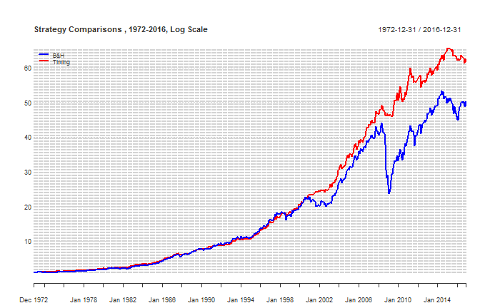

|  |  |  |  |  |  |  |
| --- | --- | --- | --- | --- | --- | --- |
|  | 1972-2005 | | 1972-2012 | | 1972-2016 | |
|  | B&H | Timing | B&H | Timing | B&H | Timing |
| CAGR | 11.30% | 11.58% | 9.98% | 10.61% | 9.29% | 9.84% |
| Volatility | 8.98% | 6.93% | 10.27% | 7.01% | 10.09% | 6.87% |
| Skew | -0.45 | -0.48 | -1.09 | -0.54 | -1.02 | -0.48 |
| Kurtosis | 1.48 | 2.57 | 5.23 | 2.41 | 5.06 | 2.35 |
| Inflation CAGR | 4.77% | 4.77% | 4.33% | 4.33% | 4.04% | 4.04% |
| % in the Market | 100.00% | 72.29% | 100.00% | 71.23% | 100.00% | 70.81% |
| % positive Months | 67.76% | 73.55% | 66.94% | 72.14% | 65.60% | 70.51% |
| Best Month | 9.10% | 6.58% | 9.22% | 6.58% | 9.22% | 6.58% |
| Worst Month | -9.23% | -9.29% | -19.34% | -9.29% | -19.34% | -9.29% |
| Max Drawdown | -19.61% | -9.56% | -46.10% | -9.56% | -46.10% | -9.56% |
| Max Drawdown / CAGR | 1.74 | 0.83 | 4.62 | 0.90 | 4.96 | 0.97 |
| Sharpe Ratio (4.93%) | 0.52 | 0.72 | 0.42 | 0.70 | 0.41 | 0.68 |
| Sortino Ratio | 0.62 | 0.88 | 0.44 | 0.77 | 0.42 | 0.73 |
| MAR Ratio | 0.58 | 1.21 | 0.22 | 1.11 | 0.20 | 1.03 |
| Ulcer Index | 4.05 | 1.73 | 8.09 | 2.29 | 7.95 | 2.36 |

Reviewing the performance of the GTAA strategy since Faber first published his research in 2006, it appears the absolute performance and risk adjusted performance has decreased and may be slightly below any expectations set by the original research paper. The CAGR for both the buy and hold strategy and the timing strategy has decreased by approximately 2% whilst volatility has remained fairly constant, or in the buy and hold strategy’s case increased.

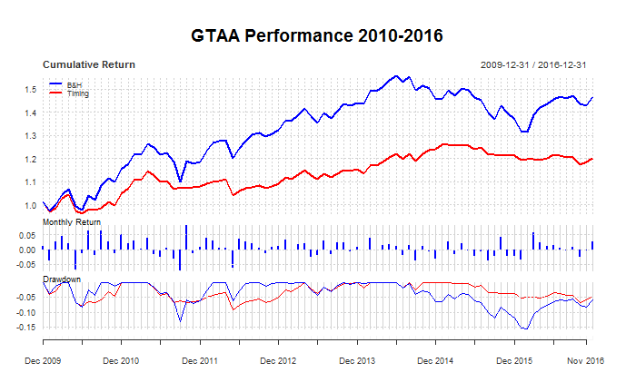

Investors who joined the timing strategy in 2006 would have been initially happy with the performance, as its timing mechanism removed their exposure to the market during the great financial crisis in 2008 resulting in limiting drawdowns to single figures despite the comparison buy and hold strategy suffering its greatest drawdown since 1972 of 46.1%. However since then, most equity markets have recovered and between 2010-2016, investors in the timing strategy expecting double figure absolute returns have experienced a CAGR of 2.63% vs 5.59% for the buy and hold. As major benchmarks such as the S&P and Dow Jones Indices make regular headlines for reaching new all time highs, it’s easy to imagine investors questioning their choice of strategy during these recent years. [show rolling performance/alpha vs S&P/bias]

# Analysis of performance

## Diversification and Modern Portfolio Theory

One of the core drivers of the absolute returns of the strategies within Faber’s paper is diversification. “Diversification is often spoken of as the only free lunch in investing” (Jennings & Payne, 2016) and has the ability to enhance returns without necessarily increasing risk. The proverb “don’t put all your eggs in one basket” explains it succinctly; invest in a portfolio of different assets and you’ll always have less (or at most equal) risk to the riskiest asset on its own. The benefits of diversification aren’t secret and have been acknowledged for thousands of years. Even the bible, thought to have been written by Solomon around 900BC, tells the reader to “divide your investments among many places, for you do not know what risks might lie ahead” (Ecclesiastes 11:2). Today some successful hedge fund managers see diversification as “the single most important factor to influence the overall long term results” (Clenow, 2013, p. 52).

In 1952 Dr Harry Markowitz published his seminal paper Portfolio Selection (1952) introducing practitioners to a mathematical framework that explained the well-known benefits of portfolio diversification. Stating rational investors desired returns and disliked variance, he hypothesised the E-V rule used to create efficient portfolios of diversified securities. Although admitting that diversification could not completely eliminate all variance, by using the E-V rule an investor is able to derive an optimal portfolio of assets with either the lowest risk for a given level of expected return or the highest expected return for a given level of risk. Markowitz’s paper notes that although the E-V rule identifies diversification as a driver for more efficient portfolios, it requires the right kind of diversification with a selection of securities with low covariance among themselves. Markowitz’s work contributed to what is known today as Modern Portfolio Theory and eventually won him a Nobel prize in 1990.

Modern Portfolio Theory has several criticisms however. The risk, return and correlation inputs into the model are based on expected values assumed to stay constant over time and returns are assumed to follow a Gaussian/normal distribution. Risk in modern portfolio theory is represented by variance, however its questionable whether rational investors will still dislike variance when an asset is moving in their desired direction. Modern portfolio theory manages risk through diversification however it ignores that during extreme market panic, correlations tend towards one.

[insert chart of correlations between 5 asset classes].

Global financial market crises in the 1987 (Black Monday), 1998 (Russian Crisis), 2001 (Dot Com Bubble and September 11) and 2008 (Global Financial Crisis/Subprime Mortgage Crisis) have shown that in these times markets tend to behave as one (Sandoval Jr & Franca, 2010). In its these periods that diversification does little to reduce downside risk and where trend following market timing strategies can add value to a diversified portfolio.

Trend following is a simple concept – identify a trend and follow it. When things move against you or when the trend is no longer there, take your profits or cut your losses. The strategy has had plenty of criticism over the years especially from classical economists supporting efficient markets. However strong performance numbers, especially during periods of extreme equity markets drawdowns, has seen the use of trend following rapidly grow as an investment strategy over the last 40 years.

Greyserman & Kaminski (2014) analyse the performance of trend following from 1223 to 2013 using a simple trend following strategy over a unique dataset for 84 markets in equity, fixed income, foreign exchange and commodity markets. They find trends exist in market prices due to fundamental, technical and behaviour reasons but ultimately conclude that trend followers don’t care about the underlying reason and just want to ride the trend whenever the opportunity arrives. They find the driver of performance in a trend following strategy to be the ability to cut losses and take profits rather than the entry signal to get into the trend. Michael Covel (Covel, 2013) identifies that trend following traders use mechanical trading systems to gain this ability to cut losses and take profits. Mechanical trading systems are based on an objective set of rules and remove discretionary decisions subject to emotion and behavioural biases.

Ultimately trend following strategies are risk reduction techniques. They remove exposure to a position during long periods of drawdown without necessarily penalising overall long term returns. A simple mechanical trend following strategy helps to avoid cognitive biases humans exhibit when making trading decisions such as anchoring bias, loss aversion, illusion of control. By managing the downside, returns that are usually negative skewed with excess kurtosis become less negative and in some cases positive skewed. [insert charts comparing buy and hold vs timing returns to show mean/skew/kurtosis]. Faber (Faber, 2007) identifies that most common asset classes experience painful drawdowns with multiple examples of 40-100% drawdowns. Trend following reduces volatility and by being out of markets during substantial periods of decline avoids long painful drawdowns for the investor.

Faber’s simple five asset class equal weighted asset allocation, even on a buy and hold basis, presents evidence of the benefits of diversification. The trend following timing overlay manages risk and results in reduction of volatility from 20% to 10%. Crucially the timing signal reduces portfolio drawdowns to the point that the investor only experience one down year since 1973, with that being -1%. Trend following isn’t about achieving superior absolute returns – it’s about avoiding the painful drawdowns which can destroy many previous years of gains. This combined with the power of compounding may result in equal or even better absolute returns, however more importantly consistently provides improved risk adjusted returns.

## Recent Performance and the Financialisation of Commodities

It’s apparent since Faber originally published his first working paper in 2006, performance numbers of the equal weighted 5 asset class buy and hold portfolio haven’t been as impressive. With the global financial crash in 2008, CAGR between 2006-2016 dropped to 3.61% compared to the 11.30% seen between 1973-2005. Volatility also increased from 8.98% to 12.74% and perhaps most painfully felt by investors, the model had its biggest drawdown ever experiencing a drawdown of 46.1% which was more than double compared to the previous periods max drawdown of 19.61%. The Sharpe ratio from 1973-2005 of 0.52 dropped to 0.20 in the following 10 years. Did Faber suffer from hindsight bias selected his equal weighted buy and hold portfolio or can this drop in performance of the last 10 years be explained elsewhere?

Reviewing the individual returns of each asset class between 2006-2016, it’s clear that commodities were the worst performing asset class and were largely responsible for dragging the overall performance of the diversified buy and hold portfolio down. Since 2006, commodities have a CARG of -8.47%, volatility higher than all other asset classes of 23.33%, as well as a max drawdown of 80.9% in a period where equity and bond returns have continued to show a positive CAGR despite also suffering significant drawdowns in the global crisis of 2008 where they lost over half their value.

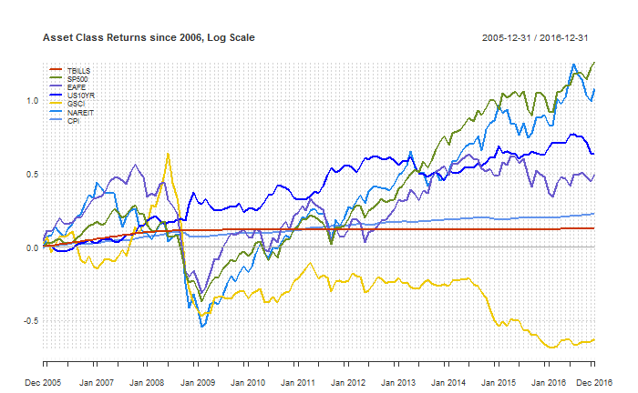

With hindsight if commodities were excluded from the buy and hold portfolio over the last 10 years, absolute and risk adjusted returns would have been considerably better for both the buy and hold strategy and the GTAA timing strategy.

|  |  |  |  |  |
| --- | --- | --- | --- | --- |
| 2006-2016 | B&H | Timing | B&H ex GSCI | Timing ex GSCI |
| CAGR | 3.61% | 4.84% | 6.36% | 6.35% |
| Volatility | 12.74% | 6.49% | 12.61% | 6.65% |
| Skew | -1.39 | -0.61 | -1.03 | -0.21 |
| Kurtosis | 5.76 | 1.80 | 4.29 | 0.20 |
| Inflation CAGR | 1.86% | 1.86% | 1.86% | 1.86% |
| % in the Market | 100.00% | 66.32% | 100.00% | 71.05% |
| % positive Months | 59.40% | 61.65% | 61.65% | 63.16% |
| Best Month | 9.22% | 5.00% | 11.75% | 5.40% |
| Worst Month | -19.34% | -6.87% | -17.12% | -5.28% |
| Max Drawdown | -46.10% | -9.22% | -43.39% | -6.84% |
| Max Drawdown / CAGR | 12.76 | 1.91 | 6.83 | 1.08 |
| Sharpe Ratio (4.93%) | 0.20 | 0.57 | 0.41 | 0.79 |
| Sortino Ratio | 0.13 | 0.34 | 0.23 | 0.48 |
| MAR Ratio | 0.08 | 0.52 | 0.15 | 0.93 |
| Ulcer Index | 14.23 | 3.65 | 11.75 | 3.00 |

Whereas between 1972 and 2006, commodities definitely added diversifying value to the asset allocation.

|  |  |  |  |  |
| --- | --- | --- | --- | --- |
|  | B&H | Timing | B&H ex GSCI | Timing ex GSCI |
| CAGR | 11.30% | 11.58% | 10.73% | 11.15% |
| Volatility | 8.98% | 6.93% | 10.33% | 7.43% |
| Skew | -0.45 | -0.48 | -0.25 | -0.53 |
| Kurtosis | 1.48 | 2.57 | 2.39 | 3.08 |
| Inflation CAGR | 4.77% | 4.77% | 4.77% | 4.77% |
| % in the Market | 100.00% | 22.22% | 100.00% | 23.80% |
| % positive Months | 67.76% | 73.55% | 68.01% | 75.06% |
| Best Month | 9.10% | 6.58% | 15.28% | 8.10% |
| Worst Month | -9.23% | -9.29% | -11.03% | -8.61% |
| Max Drawdown | -19.61% | -9.56% | -34.09% | -9.23% |
| Max Drawdown / CAGR | 1.74 | 0.83 | 3.18 | 0.83 |
| Sharpe Ratio (4.93%) | 0.52 | 0.72 | 0.41 | 0.62 |
| Sortino Ratio | 0.62 | 0.88 | 0.51 | 0.74 |
| MAR Ratio | 0.58 | 1.21 | 0.31 | 1.21 |
| Ulcer Index | 4.05 | 1.73 | 6.55 | 2.25 |

It’s not the first financial crash in this period yet performance numbers were much more effected by the performance of commodities over the last 10 years. Why? It appears commodity correlation to SP500, EAFE and NAREIT increased to the highest levels they have been since 1972.

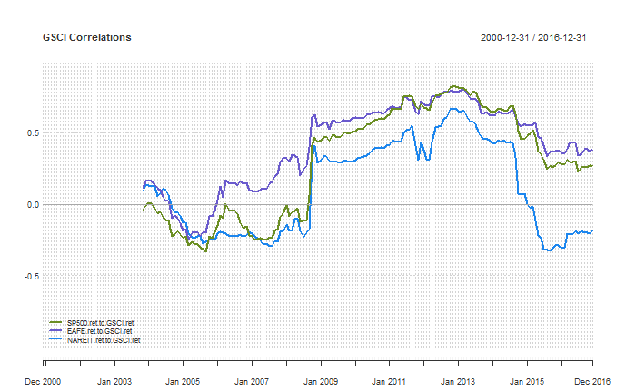

A popular topic in research around the time of Faber’s first white paper was the strong diversifying performance of commodities. Two years before Faber first released his first working version, (Gorton & Rouwenhorst, 2004) released a working paper of Facts and Fantasies About Commodity Futures highlighting commodities as an ideal diversifier for equity and bond portfolios. They showed that an equal weighted index of commodity futures between 1959 and 2004 produced equity-like returns, slightly lower risk than stocks as measured by standard deviation and less downside risk due to positively skewed returns with relatively high kurtosis. With a negative correlation with both stocks and bonds over most horizons, they concluded commodities as being an especially effective in providing diversification over both stock and bond portfolios.

Following this, in 2006 Ibbotson Associates released a report for PIMCO titled Strategic Asset Allocation and Commodities (Ibbotson Associates, 2006) that analysed the role of commodities within a strategic asset allocation setting. Comparing the returns from 1970 to 2005 of a composite commodity index against US and International stocks, US and International Bonds, Treasury Bills and Inflation, they found that commodities were the top performing asset. During periods of high inflation commodities had the highest arithmetic and compounded returns by a wide margin and in periods of low margin they still returned double digit returns. Ibbotson Associates also identified that commodities had the lowest average correlation to the other asset classes, concluding that including commodities in an asset allocation improved the risk return characteristics of the efficient frontier.

These papers combined with other literature (Erb & Harvey, 2006) drove increased long only investment into commodities financial instruments by managers looking to improve risk adjusted portfolio performance. Hundreds of billions of dollars (Irwin and Sanders, 2011 and Bhardwaj, Gorton and Rouwenhorst, 2014) of inflows into commodity investments created structural changes later termed financialisation by Domanski and Heath (2007)

As a result of financialisation, it was thought commodities were no longer driven purely by commodity fundamentals and rather by macroeconomic views of investment managers, increasing correlations among commodities and other asset classes. Zaremba (2015) provides one of the more intuitive explanations for this increase in correlation. With an increased number of financial investors holding on to a similar asset allocation of stocks, bonds and commodities, any external shock causing severe capital outflows will enforce selling of all asset classes in the portfolio at the same time to free up capital, causing correlation to rise. A resulting theme in recent research [Silvennoinen and Thorp 2009, Cheung and Miu 2010, Bhardwaj, Gorton, and Rouwenhorst 2014] reviews financialisation and the recent performance of the commodities sector since financialisation and raised the idea that commodities should no longer be included in a diversified investment portfolio. They conclude that commodities may no longer provide diversifying protection in future times of financial distress similar to the global financial crisis of 2008.

Today there are arguments for both including and excluding commodities in an asset allocation. On one hand commodity correlations have returned towards pre 2008 financial crisis levels and there is a wealth of recent research [Bhardwaj, Gorton, Rouwenhorst 2015, Levine, Ooi and Richardson 2016] reporting commodities to have strong returns during periods of growth and high inflation as well as low correlation with stocks and bonds over long horizons, concluding that despite the most recent years performance commodity futures are still likely to add diversification protection to a portfolio of assets under these regimes.

On the other hand, many (Zaremba 2015, Lombardi and Ravazzolo 2013) have argued that the diversification benefits of commodity may not be valid anymore. Due to the structural changes from the financialisation of commodities, increased correlations especially during macro market shocks, it has been argued that commodities no longer offer diversification protection for a portfolio with stocks and bonds during a financial crisis. Antonacci (2017) also argues that due to the nature of commodity markets changing from financialisation, the papers using data before this period succumb to aggregation bias and will have less forecasting power for the period following financialisation.

Without being able to predict the future and prove which argument is correct, it’s perhaps now a good time to review the performance of the timing model between 2006-2016. Like the buy and hold portfolio, returns were less than expected (4.84% vs 11.58%) however volatility reduced resulting in a far less decrease of the Sharpe ratio than expectations. Most importantly for investors, the max drawdown stayed in line with expectations and was only -9.22% in a period with another financial crisis and the buy and hold experienced a 46.10% drawdown. Its apparent that the trend following timing strategy may mitigate some of the negative impact of financialisation during crises, removing the investor from commodities during sharp drawdowns. Potentially entering a period where expectations are that inflation and growth will increase, supports including commodities in the diversified portfolio. The timing strategy allows the investor to gain any potential upside under these regimes, whilst protecting the investor somewhat in a future financial crisis, where it’s not unreasonable to expect correlations to again increase towards one for all asset classes.

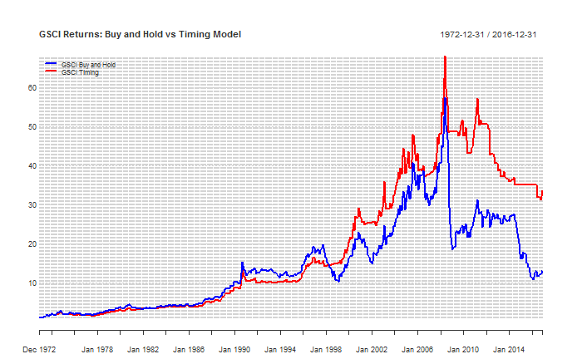

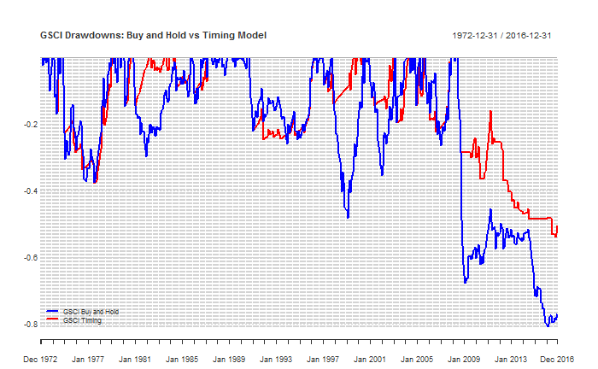

## Performance under rising interest rates

It’s well acknowledged that the world has just experienced one of the longest bull markets for fixed income. US Government 10 year Bond yields have steadily fallen from all times highs of approx. 16% in 1981 to approx. 2% today. This has resulted in a 30+ year bull market for bond returns.

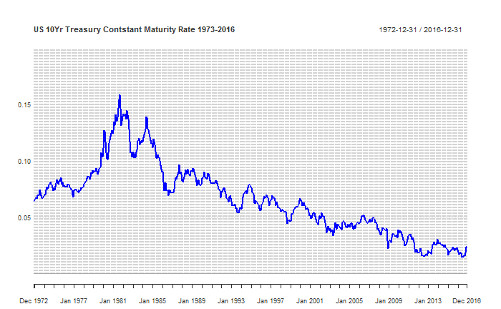

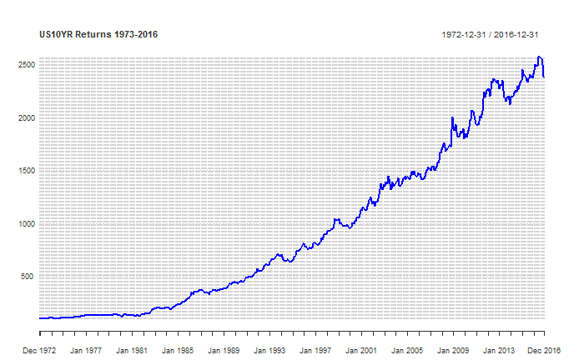

Inflammatory headlines are common, especially regarding CTA or trend following performance in a rising rates cycle. Due to its relative increasing and relative popularity, some investors are concerned that trend following strategies only generate positive risk adjusted returns during periods of falling rates. To analysis potential performance under a rising rates regime, let’s review the period 1973-1981 where it was a clear rising rates environment.

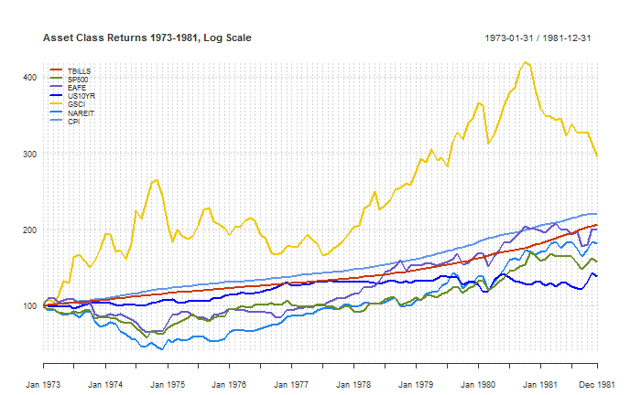

|  |  |  |  |  |  |  |
| --- | --- | --- | --- | --- | --- | --- |
|  | TBILLS | SP500 | EAFE | US10YR | GSCI | NAREIT |
| Return | 8.41% | 5.19% | 7.97% | 3.65% | 12.81% | 6.85% |
| Volatility | 0.89% | 16.56% | 16.96% | 9.27% | 23.53% | 22.15% |
| Sharpe (8.41%) | 0.00 | -0.18 | -0.03 | -0.48 | 0.17 | -0.07 |
| MaxDD | 0.00% | -42.65% | -41.53% | -15.75% | -37.45% | -58.10% |
| Inflation CAGR | 9.23% | 9.23% | 9.23% | 9.23% | 9.23% | 9.23% |

Reviewing the performance of the GTAA during the period of rising interest rates, the timing strategy was invested 70.81 of the time.

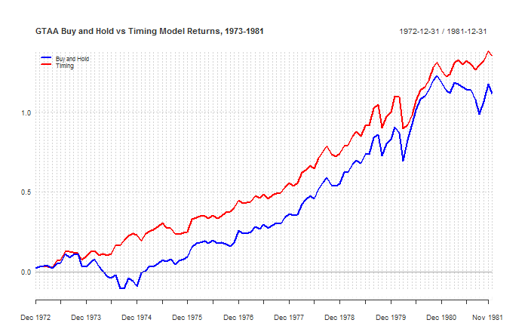

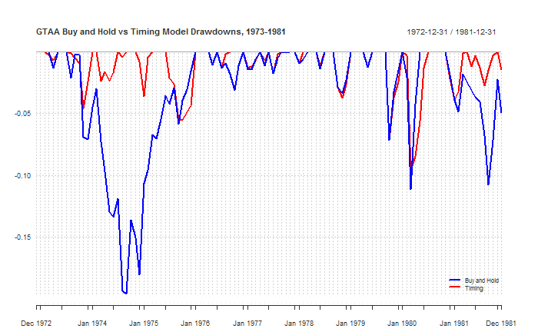

|  |  |  |
| --- | --- | --- |
|  | Buy and Hold | Timing |
| CAGR | 8.61% | 9.86% |
| Volatility | 10.79% | 8.14% |
| Skew | -0.33 | -0.80 |
| Kurtosis | 1.20 | 3.08 |
| Inflation CAGR | 9.23% | 9.23% |
| % in the Market | 100.00% | 68.07% |
| % positive Months | 60.55% | 69.72% |
| Best Month | 9.10% | 6.57% |
| Worst Month | -9.23% | -9.29% |
| Max Drawdown | -19.61% | -9.56% |
| Max Drawdown / CAGR | 2.28 | 0.97 |
| Sharpe Ratio (4.93%) | 0.00 | 0.14 |
| Sortino Ratio | 0.39 | 0.58 |
| MAR Ratio | 0.44 | 1.03 |
| Ulcer Index | 5.49 | 2.20 |

Despite attractive absolute returns in today’s climate for both the buy and hold and timing strategies, higher inflation in the period makes them much less attractive on their own. The value of the timing strategy is much clearer in the risk adjusted return measures which are all significantly higher than the buy and hold strategy. It’s clear that even in an environment of rising rates, the trend following strategy adds value.

# Practical and behavioural implications for Trend Following Investors

[taxes/fees/etc/biases]

# Improving returns

Although over a long horizon the timing strategy provides respectable risk adjusted returns and improvements over the buy and hold strategy, at times it can underperform.

[insert rolling performance chart underperformance]

The underlying system in the timing strategy is a trend following system based on a simple moving average. Trend following systems are designed to capture trends, however they are subject to periods of whipsaws… There are a few well known ideas that may improve returns and are worth investigating further.

## Diversification of assets

Faber (2013) comments that his five asset class equal weighted asset allocation was chosen for simplicity and tests expanding the strategy to a 13 asset portfolio of different weightings. The addition increases the timing strategy’s absolute returns by 1.56% for similar volatility, improving the sharpe ratio from 0.73 to 0.94. Similar improvements to returns are seen in the buy and hold strategy with increased assets, highlighting again the benefits of diversification. It makes sense then to look at adding asset classes that are low correlated to the existing strategy.

One such asset class worth investigating is Bitcoin, a cryptocurrency introduced in 2008. Bitcoin falls within the third superclass of assets known as store of value assets which generally serve as a refuge during uncertainty (Greer 1997). Despite only having a short period of pricing history from late 2010, Bitcoin has so far demonstrated extremely low correlation to all other asset classes.

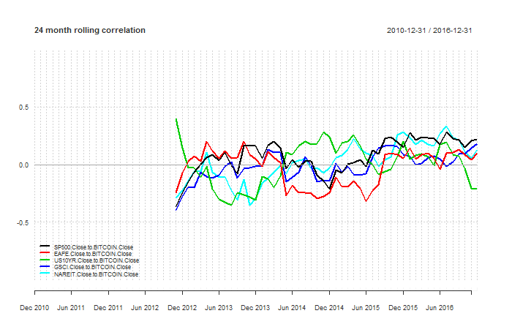

[look at extending to daily / 90d]

With a relative short history trading, Bitcoin trades on multiple unregulated exchanges and is highly volatile. Underinvested/difficult to access, less likely to suffer from the effects of financialisation witnessed in commodities and with the recent Bitcoin ETF approval rejected, there’s no obvious short term event in the near future likely to change this view... It appears that uncorrelated exposure Bitcoin seems an extremely attractive addition to the original asset allocation especially as it matures and its volatility reduces.

[insert equal weighted GTAA portfolio B&H, Timing vs GTAA with Bitcoin B&H and timing 2011-2016]

Ultimately the length of pricing history is short and the asset has yet to experience a market crisis. Without falling subject to the law of small numbers and gambler’s fallacy (Tversky and Kahneman, 1971), its unwise to make predictions of the diversifying value of adding Bitcoin to the asset allocation just yet, but for investors who can handle its volatility it’s definitely one asset class worth keeping an eye on in the future to improve returns.

Based on extensive research elsewhere, no further research was done investigating adding more assets as its generally accepted adding a limited number of additional uncorrelated assets to the asset allocation will improve returns.

## Avoiding Whipsaws

Trend following strategies are designed to identify trends and react by entering trades that will stay with the trend for as long as it lasts. The trading philosophy doesn’t attempt to predict the bottom or top of a market but rather react to a price move and capture as much of the remainder while it lasts. A drawback with trend following strategies is that performance generally suffers in consolidating, non trending or range bound markets. These sideways moving markets generate several false entry signals as the price whipsaws and quickly moves through the moving average in both directions, resulting in multiple buy and sell signals and trades for a small loss each time. Ultimately these periods are responsible for the low overall 30-40% win rate of trend following strategies

[insert chart of one asset when whipsawing with performance/P&L]

On average the size of the winners when the market is trending is much greater than the several small losses, resulting in the positive expectancy of these types of strategies. To avoid whipsaws, there are a couple of methods that can be used which will be applied to the GTAA:

* Delayed entry
* Bands
* Slope of moving average

Ultimately these delay entry into a trade or require greater certainty that a trend is present. As a result they are generally in the market less, can miss short term whipsaws but at the expense of missing out of the first part of the move. However the avoidance of costly whipsaw periods in prolonged sideways moving markets can justify their use.

## Delayed entry

This method delays long entry for a set period after a long signal to confirm that the price is still above the moving average and has not fallen back below. It eliminates whipsaws at the expense of missing out of the first part of the move. The delay only applies to the entry of a long position, and if the price falls below the moving average, the position is closed out instantaneously. Looking at the SP500 for the entire period, the value of the strategy does not look significantly different to the timing strategy. Absolute and Risk Adjusted Return metrics are all in line, perhaps the biggest difference is that the strategy is in the market only 69.19% of the time vs the 74.67% of the timing strategy.

|  |  |  |  |
| --- | --- | --- | --- |
|  | B&H | Timing | Timing Delayed |
| CAGR | 10.19% | 10.35% | 10.03% |
| Volatility | 15.28% | 11.61% | 11.22% |
| Skew | -0.43 | -0.68 | -0.71 |
| Kurtosis | 1.97 | 5.19 | 6.13 |
| Inflation CAGR | 4.04% | 4.04% | 4.04% |
| % in the Market | 100.00% | 74.67% | 69.19% |
| % positive Months | 61.63% | 73.35% | 75.24% |
| Best Month | 16.81% | 13.47% | 13.47% |
| Worst Month | -21.54% | -21.54% | -21.54% |
| Max Drawdown | -50.95% | -23.29% | -23.26% |
| Max Drawdown / CAGR | 5.00 | 2.25 | 2.32 |
| Sharpe Ratio (4.93%) | 0.33 | 0.44 | 0.43 |
| Sortino Ratio | 0.32 | 0.42 | 0.42 |
| MAR Ratio | 0.20 | 0.44 | 0.43 |
| Ulcer Index | 14.45 | 6.19 | 5.93 |

Focusing on a specific period that the SP500 was subject to whipsaws in 1977-1978, the delayed timing strategy is much more hesitant to enter a long position when the price moves above the moving average. It is only in the market 32% of the time compared to 48% of the time for the Timing strategy. Absolute performance is positive as it ignores two opportunities to enter the market that the tradional timing model took and immediately got whipsawed out of the trade. [add buy and sell signals with quantstrat]

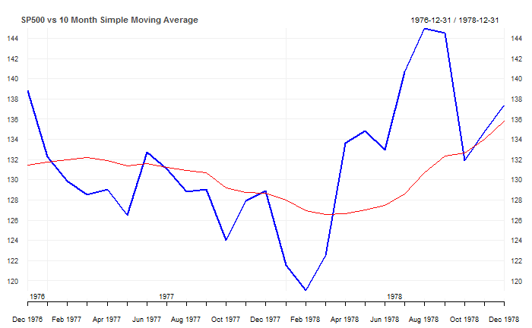

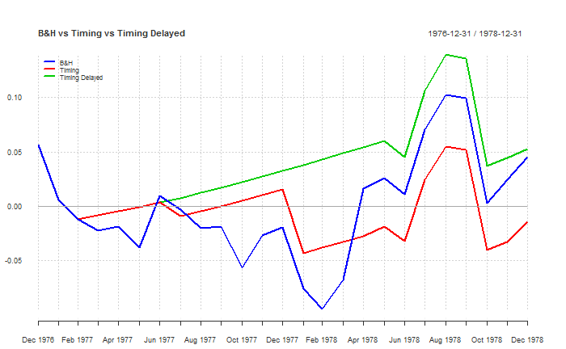

|  |  |  |  |
| --- | --- | --- | --- |
|  | B&H | Timing | Timing Delayed |
| CAGR | 2.13% | -0.67% | 2.48% |
| Volatility | 13.66% | 10.51% | 9.52% |
| Skew | 0.00 | -0.84 | -1.03 |
| Kurtosis | 0.09 | 1.93 | 3.81 |
| Inflation CAGR | 7.77% | 7.77% | 7.77% |
| % in the Market | 100.00% | 48.00% | 32.00% |
| % positive Months | 52.00% | 72.00% | 80.00% |
| Best Month | 9.02% | 5.84% | 5.84% |
| Worst Month | -8.72% | -8.72% | -8.72% |
| Max Drawdown | -14.26% | -9.39% | -9.01% |
| Max Drawdown / CAGR | 6.69 | -14.06 | 3.63 |
| Sharpe Ratio (4.93%) | -0.29 | -0.62 | -0.38 |
| Sortino Ratio | 0.10 | 0.00 | 0.12 |
| MAR Ratio | 0.15 | -0.07 | 0.28 |
| Ulcer Index | 7.29 | 6.23 | 4.37 |

## Timing Band

Introduced in 1960 by Chester Keltner, this strategy is commonly known as the Keltner Channel Trading strategy. Similar to the delayed timing strategy, this strategy requires the price to demonstrate a stronger trend than just simply crossing above the moving average. Instead the price has to close a specific range above the simple moving average, in this example 102.5% of the moving average. Commonly the range is based on the ATR indicator however for simplicity in this research 102.5% was chosen – parameter stability was evident. In this example the exit is immediately when the price falls below the moving average. Overall the strategy aims to eliminate whips at the expense of missing out the first part of any trend. Looking at the SP500 for the entire period, the value of the strategy is slightly better than the original timing strategy with slightly higher CAGR and slightly lower volatility, resulting in improved risk adjusted return metrics. Again, the strategy is in the market for a less time – 70.89% of the time vs the 74.67% of the original timing strategy.

|  |  |  |  |
| --- | --- | --- | --- |
|  | B&H | Timing | Timing Band |
| CAGR | 10.19% | 10.35% | 10.96% |
| Volatility | 15.28% | 11.61% | 11.14% |
| Skew | -0.43 | -0.68 | -0.66 |
| Kurtosis | 1.97 | 5.19 | 6.13 |
| Inflation CAGR | 4.04% | 4.04% | 4.04% |
| % in the Market | 100.00% | 74.67% | 70.89% |
| % positive Months | 61.63% | 73.35% | 75.24% |
| Best Month | 16.81% | 13.47% | 13.47% |
| Worst Month | -21.54% | -21.54% | -21.54% |
| Max Drawdown | -50.95% | -23.29% | -23.29% |
| Max Drawdown / CAGR | 5.00 | 2.25 | 2.13 |
| Sharpe Ratio (4.93%) | 0.33 | 0.44 | 0.52 |
| Sortino Ratio | 0.32 | 0.42 | 0.47 |
| MAR Ratio | 0.20 | 0.44 | 0.47 |
| Ulcer Index | 14.45 | 6.19 | 5.36 |

Focusing on a specific period that the SP500 was subject to whipsaws in 1977-1978, the timing band makes it harder to enter a long position as the price closing just above the moving average is not strong enough to signal entry. It is in the market 36% of the time compared to 48% of the time for the original timing strategy. Absolute performance is positive as it ignores two opportunities to enter the market that the traditional timing model took and immediately got whipsawed out of the trade. [add 102.5% dotted line…]



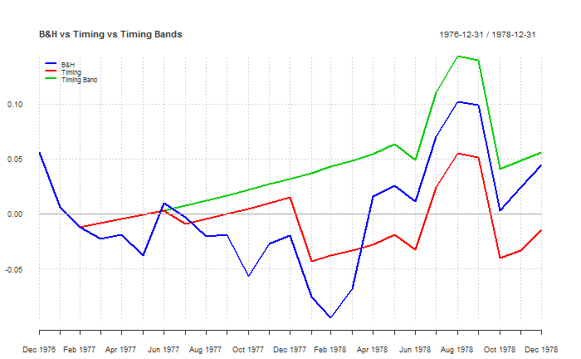

|  |  |  |  |
| --- | --- | --- | --- |
|  | B&H | Timing | Timing Band |
| CAGR | 2.13% | -0.67% | 2.67% |
| Volatility | 13.66% | 10.51% | 9.53% |
| Skew | 0.00 | -0.84 | -1.05 |
| Kurtosis | 0.09 | 1.93 | 3.80 |
| Inflation CAGR | 7.77% | 7.77% | 7.77% |
| % in the Market | 100.00% | 48.00% | 36.00% |
| % positive Months | 52.00% | 72.00% | 80.00% |
| Best Month | 9.02% | 5.84% | 5.84% |
| Worst Month | -8.72% | -8.72% | -8.72% |
| Max Drawdown | -14.26% | -9.39% | -9.01% |
| Max Drawdown / CAGR | 6.69 | -14.06 | 3.37 |
| Sharpe Ratio (4.93%) | -0.29 | -0.62 | -0.36 |
| Sortino Ratio | 0.10 | 0.00 | 0.13 |
| MAR Ratio | 0.15 | -0.07 | 0.30 |
| Ulcer Index | 7.29 | 6.23 | 4.37 |

## Strategy Diversification

The value of diversification is widely known and previously acknowledged. For a buy and hold investment strategy, diversification is limited to the choice of assets invested. In an active approach to investing, diversification can be applied to all variables within a trading strategy including the type of indicator used as an entry or exit signal, the signal’s time period as well as strategy’s direction (long or short).

Peter Garnby (2016) demonstrates that weak individual trading strategies, which individually offer low risk adjusted returns, can be combined into a superior portfolio with much stronger risk adjusted returns. Over 500 trials he simulates blending 20 individual strategies each with individual sharpe ratios of 0.6 into portfolios that run for 10 years. Although absolute returns are not necessarily enhanced, he finds that portfolios of low correlated strategies return significantly improved risk adjusted performance with portfolio Sharpe Ratios of 3, a 370% improvement. The portfolio risk adjusted returns quickly decline as correlation increases, however the research shows the benefits of diversification can also be achieved by combining low correlated timing strategies.

Applying this knowledge to Faber’s timing strategy can be achieved in multiple ways. One of the simplest methods would be by diversifying the timing signal moving average period. Faber acknowledges that stability of using various parameters for the moving average period. Faber uses the 10m moving average and compares the returns to 3, 6, 9 and 12 month moving averages to find similar returns. Another two popular signals in the trend following community are the 50day and 100 day moving averages. Converted to monthly 2m and 5m, how does an equal weighted portfolio of the 3 different moving average timing strategies perform:

|  |  |  |  |  |  |
| --- | --- | --- | --- | --- | --- |
|  | B&H | 2M Timing | 5M Timing | 10M Timing | Multi Timing |
| CAGR | 9.29% | 9.49% | 9.27% | 9.84% | 9.57% |
| Volatility | 10.09% | 6.29% | 6.62% | 6.87% | 6.14% |
| Skew | -1.02 | -0.07 | -0.51 | -0.48 | -0.25 |
| Kurtosis | 5.06 | 2.55 | 2.61 | 2.35 | 1.30 |
| Inflation CAGR | 4.04% | 4.04% | 4.04% | 4.04% | 4.04% |
| % in the Market | 100.00% | 59.89% | 65.48% | 70.81% | 0.00% |
| % Positive Months | 65.60% | 71.27% | 70.13% | 70.51% | 70.13% |
| Best Month | 9.22% | 9.22% | 6.57% | 6.58% | 6.18% |
| Worst Month | -19.34% | -7.96% | -9.29% | -9.29% | -6.11% |
| Max Drawdown | -46.10% | -13.29% | -10.71% | -9.56% | -8.65% |
| Max Drawdown / CAGR | 4.96 | 1.40 | 1.16 | 0.97 | 0.90 |
| Sharpe Ratio (4.93%) | 0.41 | 0.69 | 0.62 | 0.68 | 0.72 |
| Sortino Ratio | 0.42 | 0.83 | 0.71 | 0.73 | 0.84 |
| MAR Ratio | 0.20 | 0.71 | 0.87 | 1.03 | 1.11 |
| Ulcer Index | 7.95 | 2.39 | 2.66 | 2.36 | 2.11 |

Similar to Faber’s findings, each timing signal returns individual performance with similar absolute returns, volatility and risk adjusted measures such as Sharpe Ratio. When combined into an equal weighted strategy, the multi timing strategy shows similar absolute returns as expected from Garnby’s findings. However volatility and maxdd are the lowest and as a result risk adjusted measures such as Sharpe ratio, Sortino ratio, Calmar ratio and Ulcer index are all the best

Diversification of strategies can also be applied to include the other timing strategy ideas. A multi strategy portfolio consisting of equal weight exposure to the following strategies:

* 2m, 5m, 10m timing signal strategies
* 2m, 5m, 10m, delayed timing signal strategies
* 2m, 5, 10m trading band strategies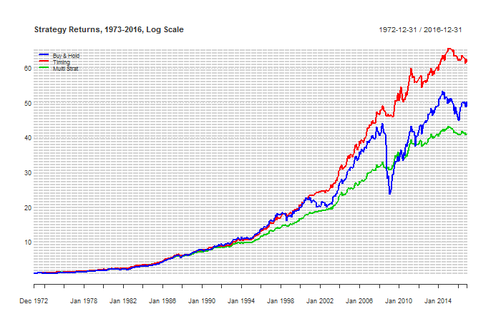

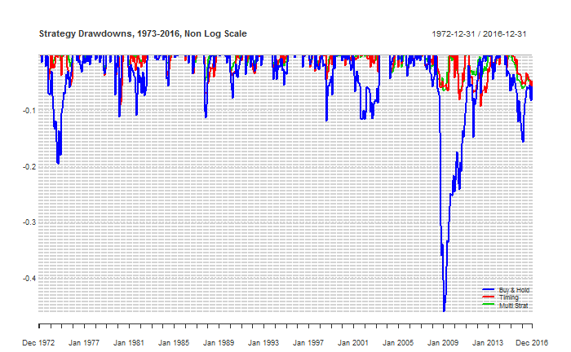

|  |  |  |  |
| --- | --- | --- | --- |
|  | B&H | Timing | Multi Strat |
| CAGR | 9.29% | 9.84% | 8.80% |
| Volatility | 10.09% | 6.87% | 5.49% |
| Skew | -1.02 | -0.48 | -0.33 |
| Kurtosis | 5.06 | 2.35 | 2.22 |
| Inflation CAGR | 4.04% | 4.04% | 4.04% |
| % in the Market | 100.00% | 70.81% | 55.04% |
| % positive Months | 65.60% | 70.51% | 72.02% |
| Best Month | 9.22% | 6.58% | 6.18% |
| Worst Month | -19.34% | -9.29% | -6.57% |
| Max Drawdown | -46.10% | -9.56% | -6.93% |
| Max Drawdown / CAGR | 4.96 | 0.97 | 0.79 |
| Sharpe Ratio (4.93%) | 0.41 | 0.68 | 0.67 |
| Sortino Ratio | 0.42 | 0.73 | 0.85 |
| MAR Ratio | 0.20 | 1.03 | 1.27 |
| Ulcer Index | 7.95 | 2.36 | 1.82 |

Although absolute returns are less but nearly a whole percentage point, lowering the volatility and max drawdown potentially allows the investor to take on more leverage to achieve enhanced total returns.

Note the above numbers exclude trading costs / taxes / etc talked about in practical considerations. Lastly all of the above ignores trading fees… Downside is costs/taxes however with these assets trading costs are assumed to be minimal and worth the better returns. Taxes also are fine – fabers comments about winners being longer, etc.

# A Quantitative Approach to Tactical Asset Allocation in South Africa

South Africa has a very traditional investment industry that has lagged the world adopting recent investment trends such as indexation (Morningstar 2015). It is estimated that X% of funds invested are actively managed and of these funds a large majority are discretionary managed rather than quantitative. How will a quantitative strategy like Faber’s perform when applied to local assets and compare to the top ranking managers.

## Data

The biggest challenge to apply the strategy to South Africa is obtaining a long enough period of historical price data for each asset class in South Africa. (all, 2016). Ibbotson et al (2016) view long periods of data as vital for uncovering “the basic the relationships between risk and return among the different asset classes”. With a long enough period, the data will capture major market events as well as periods under different regimes such as growth and decline or inflation and deflation. Although history is unlikely to repeat, infamous market crashes and financial crises in different asset classes around the world are common throughout history all the way back to the 1600s with the infamous tulip bubble crash. In one way or another, despite the common view that markets walk a random path, it shows that history tends to repeat itself and a long period of data may hold some level of predictive value in the future.

Unfortunately for South Africa, historical performance data for each asset class is difficult to find for long periods of history and near impossible for asset classes such as property. Domestic equity market data is available from the local Johannesburg Stock Exchange going back to 1960 however even they cannot guarantee that the data is completely accurate as some of it was captured prior to the current FTSE/JSE joint venture in 2002. Previous local research (Firer and McLeod, 1999) found that before 1960 data was never systematically collected and published. It was found during this study, that previous work collecting data (including Firer and McLeod) had been lost once the researcher had changed career paths or unfortunately passed away. Copies of data handed down researcher to researcher exist, however the validity of some of this data is questionable especially after finding inconsistencies when reviewing and comparing time periods where multiple data sets overlap.

To create long data sets of historical returns for South African asset classes, I have used the best quality most recent data spliced to the most reliable of the available older data. This is summarised by the following table.

|  |  |
| --- | --- |
|  | Source |
| Domestic Equities | 2002-2016: FTSE/JSE All Share Total Return Index |
| 1970-2002: JSE/Actuaries All Share Index with dividends allocated evenly over the year |
| Foreign Equities | 1971-2016: MSCI World Total Return Index in ZAR |
| Fixed Income | 2002-2016: JSE ALBI Total return index |
| 1971-2002: Total return index created using 10 yr Government Bond Yields for South Africa provided by IMF on FRED |
| Commodities | 1971-2016: S&P GSCI Total Return Index in ZAR |
| Property | 2002-2016: FTSE/JSE SA Listed Property Total Return Index |
| 1992-2002: Property sector total return data provided by local asset manager |
| Inflation | 1971-2016: South Africa CPI Index (Statistics South Africa) |
| Risk Free | 1971-2016: Risk free / Cash index created using Treasury Bill Yields for South Africa provided by IMF on FRED |

## South African Asset Class Returns excluding Real Estate (1971-2016)

[redo with log charts]

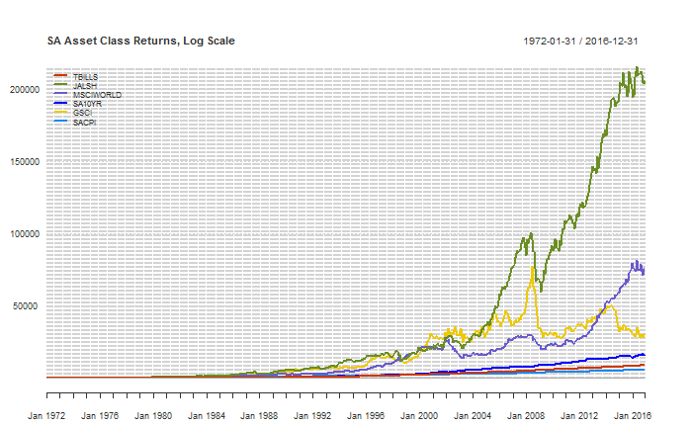

|  |  |  |  |  |  |
| --- | --- | --- | --- | --- | --- |
|  | TBILLS | JALSH | MSCIWORLD | SA10YR | GSCI |
| Return | 10.53% | 18.48% | 15.87% | 12.00% | 13.60% |
| Volatility | 1.26% | 20.99% | 17.42% | 7.35% | 22.88% |
| Sharpe (10.53%) | 0.00 | 0.34 | 0.28 | 0.18 | 0.12 |
| MaxDD | 0.00% | -42.45% | -49.90% | -18.63% | -64.08% |
| Inflation CAGR | 9.48% | 9.48% | 9.48% | 9.48% | 9.48% |

[rewrite summary and compare to US]

Reviewing the performance of asset classes in South Africa during 1972 – 2016, domestic equities have the strongest absolute CAGR of 18.48% followed by foreign equities with 15.87%. Commodities still return 13.60% for the period, highlighting the currency hedging effect a weakening ZAR has boosting returns in local currency. It’s also noteworthy that SA has much higher inflation and risk free rate than the original US asset allocation.

## Timing Signal

Let’s look at the asset returns individually and how the timing signal affect returns. It’s interesting to note with South Africa assets that the timing model consistently resulted in better risk adjusted returns, usually by a reduction in volatility than better absolute returns. JALSH was an exception – it had a worse MaxDD and equal Sharpe Ratio. [rewrite and mention this is where using multiple period moving averages or delayed entry would solve]

### JALSH – South African Domestic Equities

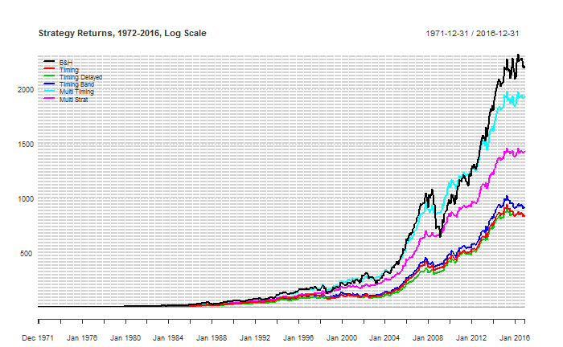 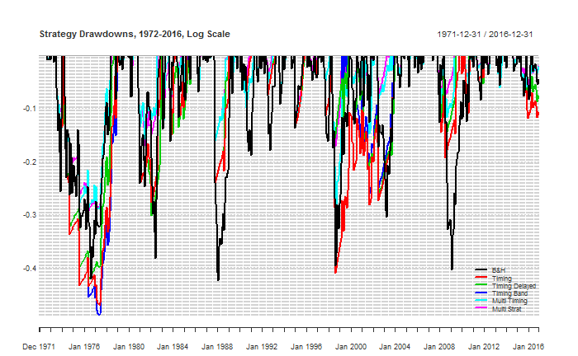

|  |  |  |  |  |  |  |
| --- | --- | --- | --- | --- | --- | --- |
|  | B&H | Timing | Timing Delayed | Timing Band | Multi Timing | Multi Strat |
| CAGR | 18.64% | 16.13% | 16.12% | 16.34% | 18.29% | 17.50% |
| Volatility | 20.99% | 17.26% | 15.96% | 16.48% | 14.90% | 13.36% |
| Skew | -0.45 | -0.66 | -0.32 | -0.28 | 0.01 | 0.20 |
| Kurtosis | 1.70 | 4.40 | 3.04 | 2.52 | 2.57 | 2.66 |
| Inflation CAGR | 9.48% | 9.48% | 9.48% | 9.48% | 9.48% | 9.48% |
| % in the Market | 100.00% | 75.42% | 69.32% | 73.75% | 69.38% | 62.88% |
| % positive Months | 61.92% | 71.53% | 74.12% | 71.90% | 69.87% | 71.16% |
| Best Month | 18.28% | 17.70% | 17.70% | 17.70% | 17.70% | 17.18% |
| Worst Month | -29.58% | -29.58% | -23.41% | -23.41% | -19.19% | -15.37% |
| Max Drawdown | -42.45% | -47.02% | -42.34% | -48.98% | -29.30% | -29.16% |
| Max Drawdown / CAGR | 2.28 | 2.91 | 2.63 | 3.00 | 1.60 | 1.67 |
| Sharpe Ratio (10.52%) | 0.34 | 0.30 | 0.32 | 0.32 | 0.47 | 0.47 |
| Sortino Ratio | 0.44 | 0.45 | 0.50 | 0.49 | 0.65 | 0.71 |
| MAR Ratio | 0.44 | 0.34 | 0.38 | 0.33 | 0.62 | 0.60 |
| Ulcer Index | 13.12 | 16.58 | 14.63 | 16.47 | 9.07 | 8.52 |

### MSCI WORLD – Foreign Developed Equities (in local currency ZAR)

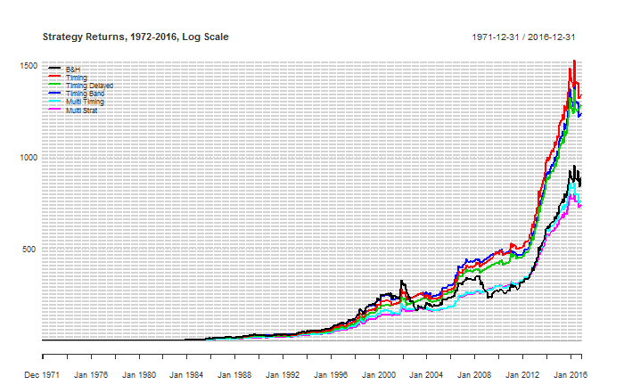

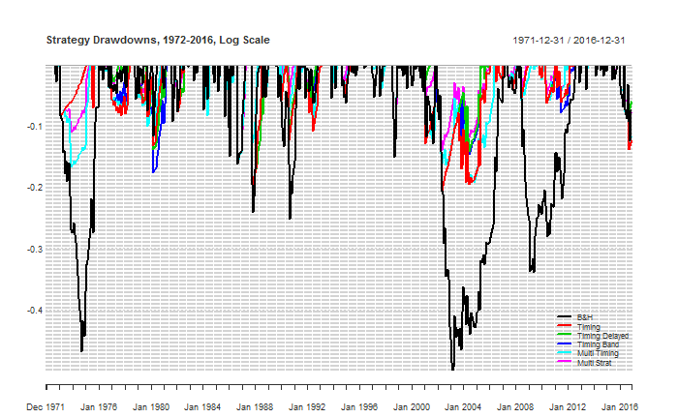

|  |  |  |  |  |  |  |
| --- | --- | --- | --- | --- | --- | --- |
|  | B&H | Timing | Timing Delayed | Timing Band | Multi Timing | Multi Strat |
| CAGR | 16.25% | 17.33% | 17.22% | 17.12% | 15.86% | 15.79% |
| Volatility | 17.57% | 15.07% | 14.55% | 14.62% | 13.53% | 12.28% |
| Skew | 0.40 | 0.69 | 0.78 | 0.74 | 0.88 | 1.14 |
| Kurtosis | 2.94 | 5.86 | 6.83 | 6.62 | 7.33 | 10.45 |
| Inflation CAGR | 9.48% | 9.48% | 9.48% | 9.48% | 9.48% | 9.48% |
| % in the Market | 100.00% | 77.45% | 71.90% | 73.20% | 70.92% | 61.72% |
| % positive Months | 62.85% | 73.57% | 75.79% | 75.60% | 71.72% | 74.49% |
| Best Month | 29.19% | 29.19% | 29.19% | 29.19% | 29.19% | 29.19% |
| Worst Month | -19.43% | -19.43% | -19.43% | -19.43% | -16.09% | -16.09% |
| Max Drawdown | -49.90% | -20.54% | -20.54% | -20.54% | -19.17% | -16.09% |
| Max Drawdown / CAGR | 3.07 | 1.19 | 1.19 | 1.20 | 1.21 | 1.02 |
| Sharpe Ratio (10.52%) | 0.28 | 0.41 | 0.42 | 0.41 | 0.35 | 0.39 |
| Sortino Ratio | 0.50 | 0.64 | 0.66 | 0.65 | 0.65 | 0.73 |
| MAR Ratio | 0.33 | 0.84 | 0.84 | 0.83 | 0.83 | 0.98 |
| Ulcer Index | 17.14 | 6.06 | 5.16 | 5.64 | 6.17 | 4.22 |

### SA10YR

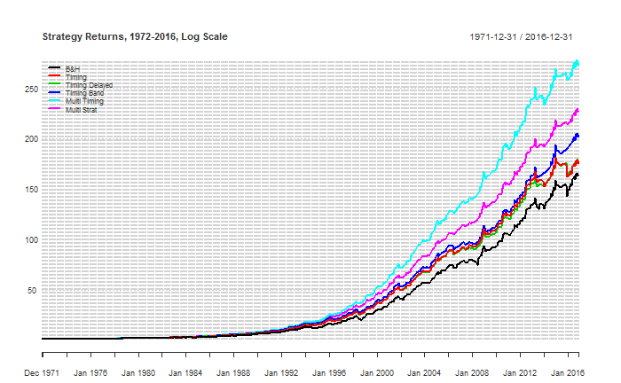

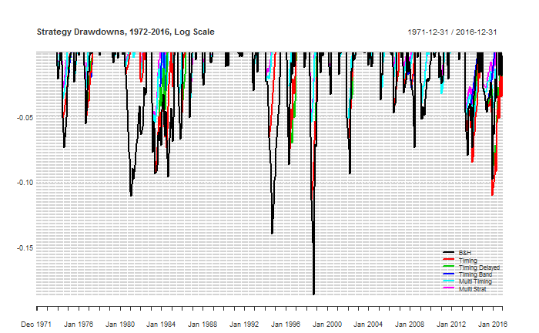

|  |  |  |  |  |  |  |
| --- | --- | --- | --- | --- | --- | --- |
|  | B&H | Timing | Timing Delayed | Timing Band | Multi Timing | Multi Strat |
| CAGR | 12.00% | 12.19% | 12.20% | 12.53% | 13.28% | 12.80% |
| Volatility | 7.35% | 6.62% | 6.50% | 6.32% | 5.93% | 5.27% |
| Skew | 0.20 | 0.05 | 0.06 | 0.17 | 0.44 | 0.47 |
| Kurtosis | 1.82 | 2.21 | 2.48 | 2.48 | 2.71 | 3.64 |
| Inflation CAGR | 9.48% | 9.48% | 9.48% | 9.48% | 9.48% | 9.48% |
| % in the Market | 100.00% | 87.43% | 83.36% | 0.00% | 80.28% | 67.53% |
| % positive Months | 73.57% | 77.82% | 78.93% | 80.22% | 80.96% | 84.47% |
| Best Month | 10.14% | 9.09% | 9.09% | 9.09% | 9.09% | 9.09% |
| Worst Month | -6.67% | -6.67% | -6.67% | -5.14% | -5.03% | -5.03% |
| Max Drawdown | -18.63% | -11.35% | -11.35% | -11.35% | -7.06% | -6.14% |
| Max Drawdown / CAGR | 1.55 | 0.93 | 0.93 | 0.91 | 0.53 | 0.48 |
| Sharpe Ratio (10.52%) | 0.18 | 0.23 | 0.23 | 0.29 | 0.42 | 0.39 |
| Sortino Ratio | 0.94 | 1.05 | 1.07 | 1.17 | 1.49 | 1.66 |
| MAR Ratio | 0.64 | 1.07 | 1.07 | 1.10 | 1.88 | 2.08 |
| Ulcer Index | 3.47 | 2.70 | 2.51 | 2.28 | 1.48 | 1.21 |

### GSCI – Commodities Index (in local currency ZAR)

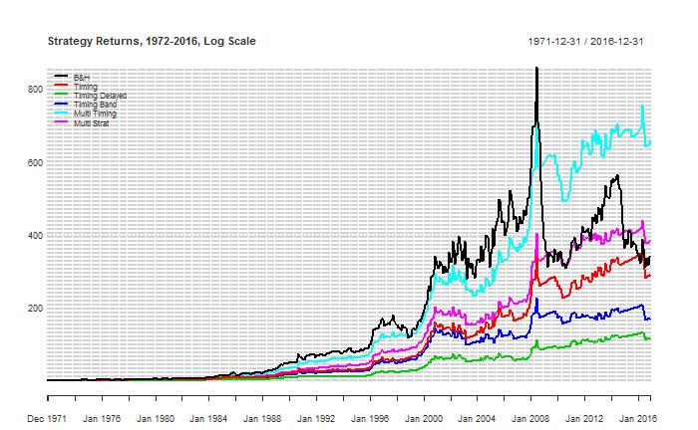 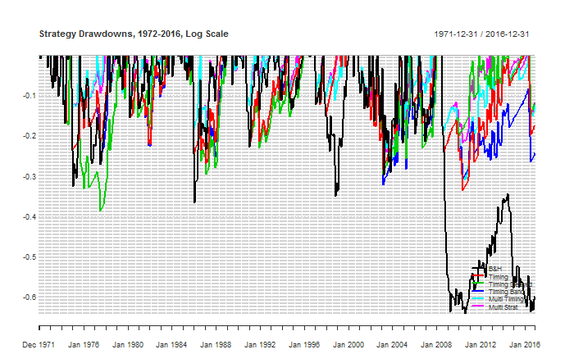

|  |  |  |  |  |  |  |
| --- | --- | --- | --- | --- | --- | --- |
|  | B&H | Timing | Timing Delayed | Timing Band | Multi Timing | Multi Strat |
| CAGR | 13.85% | 13.42% | 11.16% | 12.11% | 15.49% | 14.14% |
| Volatility | 22.91% | 19.04% | 17.38% | 18.75% | 17.11% | 15.22% |
| Skew | 0.21 | 0.59 | 0.20 | 0.63 | 0.88 | 0.51 |
| Kurtosis | 1.48 | 4.13 | 3.58 | 4.52 | 5.03 | 4.31 |
| Inflation CAGR | 9.48% | 9.48% | 9.48% | 9.48% | 9.48% | 9.48% |
| % in the Market | 100.00% | 69.32% | 62.29% | 65.62% | 64.94% | 56.48% |
| % positive Months | 59.89% | 72.46% | 74.68% | 73.38% | 70.24% | 71.90% |
| Best Month | 30.09% | 30.09% | 25.90% | 30.09% | 30.09% | 22.72% |
| Worst Month | -19.15% | -19.15% | -19.15% | -19.15% | -17.57% | -17.57% |
| Max Drawdown | -64.08% | -33.50% | -38.71% | -32.06% | -30.96% | -24.64% |
| Max Drawdown / CAGR | 4.63 | 2.50 | 3.47 | 2.65 | 2.00 | 1.74 |
| Sharpe Ratio (10.52%) | 0.12 | 0.13 | 0.02 | 0.06 | 0.25 | 0.20 |
| Sortino Ratio | 0.33 | 0.38 | 0.33 | 0.35 | 0.51 | 0.50 |
| MAR Ratio | 0.22 | 0.40 | 0.29 | 0.38 | 0.50 | 0.57 |
| Ulcer Index | 30.20 | 12.36 | 14.62 | 13.72 | 8.98 | 7.86 |

Add commentary summary for all assets:

* Again slightly less CAGR but less volatility and higher sharp / lower drawdown.
* Interesting drawdown is the same – unusual for this strategy but have checked its real
* Timing model doesn’t add much value in this case
* There is always exceptions to any rule and it appears JALSH bucks the trend with the timing model not return significantly better risk adjusted returns. Analysing why – 1988
* Demonstrates power of compounding after an early loss
* Much better results for the timing model in all performance measures
* Much better results for the timing model in all performance measures
* Most measures better.
* Interesting that the ZAR improves returns compared to USD GSCI

## Systematic Tactical Asset Allocation South Africa (1972-2016)

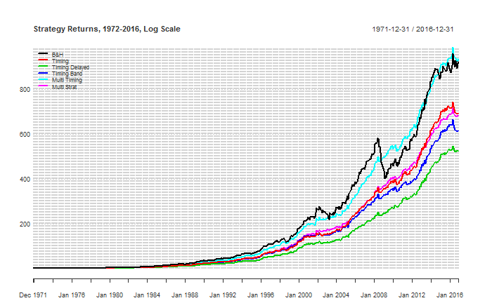

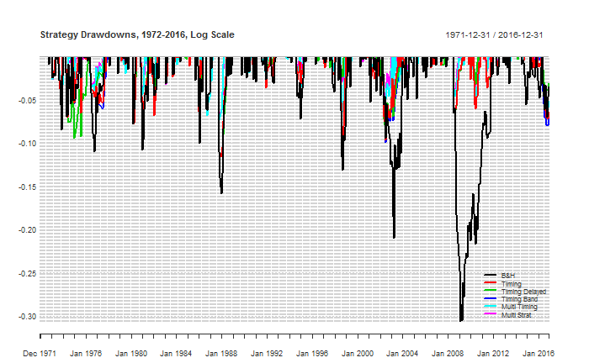

|  |  |  |  |  |  |  |
| --- | --- | --- | --- | --- | --- | --- |
|  | B&H | Timing | Timing Delayed | Timing Band | Multi Timing | Multi Strat |
| CAGR | 16.36% | 15.63% | 14.92% | 15.32% | 16.39% | 15.59% |
| Volatility | 10.95% | 8.76% | 7.96% | 8.54% | 7.87% | 7.01% |
| Skew | 0.05 | 0.08 | -0.18 | 0.19 | 0.36 | 0.32 |
| Kurtosis | 1.74 | 3.96 | 2.52 | 4.14 | 3.36 | 3.31 |
| Inflation CAGR | 9.48% | 9.48% | 9.48% | 9.48% | 9.48% | 9.48% |
| % in the Market | 100.00% | 77.40% | 71.72% | 73.24% | 71.38% | 61.93% |
| % positive Months | 66.54% | 71.90% | 73.20% | 72.27% | 74.86% | 75.23% |
| Best Month | 16.34% | 16.34% | 10.33% | 16.34% | 15.11% | 12.71% |
| Worst Month | -10.98% | -10.98% | -10.98% | -10.98% | -7.29% | -7.15% |
| Max Drawdown | -30.61% | -11.59% | -11.59% | -11.59% | -7.29% | -7.15% |
| Max Drawdown / CAGR | 1.87 | 0.74 | 0.78 | 0.76 | 0.44 | 0.46 |
| Sharpe Ratio (10.52%) | 0.47 | 0.52 | 0.50 | 0.51 | 0.67 | 0.65 |
| Sortino Ratio | 0.83 | 1.01 | 1.07 | 1.04 | 1.32 | 1.45 |
| MAR Ratio | 0.53 | 1.35 | 1.29 | 1.32 | 2.25 | 2.18 |
| Ulcer Index | 6.35 | 2.60 | 2.58 | 2.60 | 1.74 | 1.47 |

The absolute returns of the timing strategy are slightly worse however a larger drop in volatility results in a higher sharpe ratio. Importantly for investors, the biggest drawdown is 11.59%, approximately a third of the buy and hold. Risk adjusted measures are all much better than the buy and hold.

Look at rolling returns / annual returns vs benchmark

## South African Asset Class Returns including Real Estate (1994-2016)

Now lets add property and compare since 1994

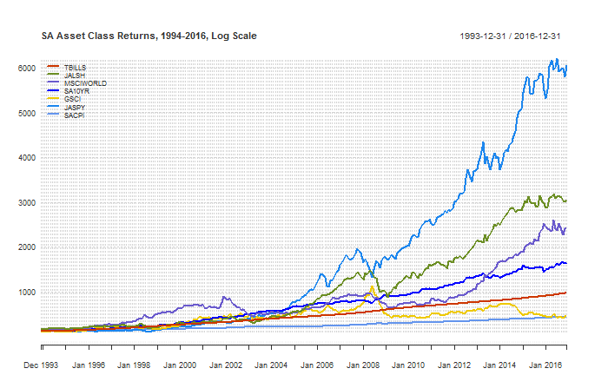

|  |  |  |  |  |  |  |
| --- | --- | --- | --- | --- | --- | --- |
|  | TBILLS | JALSH | MSCIWORLD | SA10YR | GSCI | JASPY |
| Return | 9.84% | 14.59% | 13.54% | 11.74% | 6.85% | 19.40% |
| Volatility | 1.01% | 18.37% | 16.32% | 8.04% | 23.01% | 15.85% |
| Sharpe (9.84%) | -0.14 | 0.23 | 0.20 | 0.19 | -0.13 | 0.54 |
| MaxDD | 0.00% | -40.44% | -49.90% | -18.63% | -64.08% | -31.87% |
| Inflation CAGR | 6.19% | 6.19% | 6.19% | 6.19% | 6.19% | 6.19% |

Reviewing the most recent 22 years, which includes data on Real Estate, shows that over this period Real Estate has returned much stronger absolute and risk adjusted returns than the other asset classes. Commodities again have the lowest absolute returns, despite having the highest volatility. GSCI returns of 6.91% are just higher than inflation which has reduced by approximately a third compared to the previous period.

### JSAPY – South African Real Estate Index

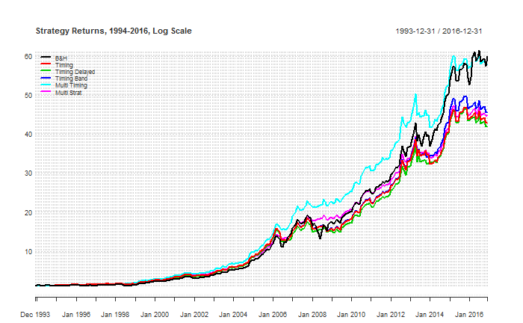

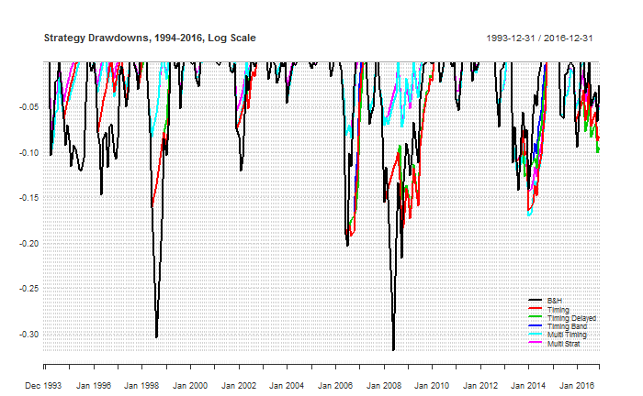

|  |  |  |  |  |  |  |
| --- | --- | --- | --- | --- | --- | --- |
|  | B&H | Timing | Timing Delayed | Timing Band | Multi Timing | Multi Strat |
| CAGR | 19.40% | 17.71% | 17.60% | 18.02% | 19.24% | 17.93% |
| Volatility | 15.85% | 13.26% | 12.87% | 13.02% | 11.53% | 10.27% |
| Skew | -0.05 | -0.18 | -0.15 | -0.17 | 0.11 | 0.12 |
| Kurtosis | 1.15 | 2.35 | 2.86 | 2.62 | 2.01 | 2.14 |
| Inflation CAGR | 6.19% | 6.19% | 6.19% | 6.19% | 6.19% | 6.19% |
| % in the Market | 100.00% | 81.23% | 76.17% | 79.42% | 74.25% | 66.75% |
| % positive Months | 66.07% | 74.01% | 76.17% | 75.09% | 74.37% | 74.73% |
| Best Month | 18.19% | 14.52% | 14.52% | 14.52% | 13.45% | 13.42% |
| Worst Month | -13.93% | -13.93% | -13.93% | -13.93% | -11.09% | -11.09% |
| Max Drawdown | -31.87% | -19.25% | -19.00% | -19.00% | -17.02% | -14.34% |
| Max Drawdown / CAGR | 1.64 | 1.09 | 1.08 | 1.05 | 0.88 | 0.80 |
| Sharpe Ratio (9.84%) | 0.55 | 0.54 | 0.55 | 0.57 | 0.75 | 0.72 |
| Sortino Ratio | 0.64 | 0.67 | 0.69 | 0.70 | 0.94 | 1.00 |
| MAR Ratio | 0.61 | 0.92 | 0.93 | 0.95 | 1.13 | 1.25 |
| Ulcer Index | 7.15 | 6.41 | 6.14 | 6.13 | 4.04 | 3.64 |

## Systematic Tactical Asset Allocation South Africa (1994-2016)

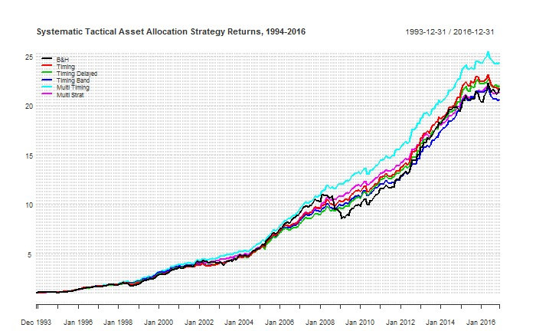

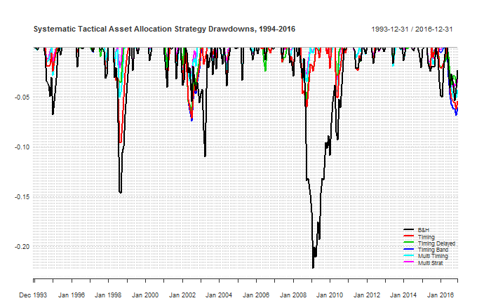

|  |  |  |  |  |  |  |
| --- | --- | --- | --- | --- | --- | --- |
|  | B&H | Timing | Timing Delayed | Timing Band | Multi Timing | Multi Strat |
| CAGR | 14.28% | 14.30% | 14.35% | 14.03% | 14.85% | 14.20% |
| Volatility | 9.44% | 7.04% | 6.47% | 6.70% | 6.29% | 5.44% |
| Skew | -0.11 | 0.03 | 0.42 | 0.21 | -0.03 | 0.11 |
| Kurtosis | 1.88 | 1.31 | 1.25 | 1.00 | 0.84 | 0.86 |
| Inflation CAGR | 6.19% | 6.19% | 6.19% | 6.19% | 6.19% | 6.19% |
| % in the Market | 100.00% | 76.17% | 70.54% | 72.42% | 70.11% | 60.87% |
| % positive Months | 65.34% | 71.48% | 74.01% | 72.56% | 75.09% | 76.17% |
| Best Month | 11.52% | 8.42% | 8.42% | 8.42% | 7.16% | 6.83% |
| Worst Month | -10.90% | -6.72% | -4.69% | -4.92% | -4.81% | -3.40% |
| Max Drawdown | -22.19% | -9.59% | -6.51% | -7.41% | -5.05% | -4.08% |
| Max Drawdown / CAGR | 1.55 | 0.67 | 0.45 | 0.53 | 0.34 | 0.29 |
| Sharpe Ratio (9.84%) | 0.43 | 0.58 | 0.64 | 0.57 | 0.73 | 0.73 |
| Sortino Ratio | 0.84 | 1.27 | 1.60 | 1.39 | 1.55 | 1.89 |
| MAR Ratio | 0.64 | 1.49 | 2.21 | 1.89 | 2.94 | 3.48 |
| Ulcer Index | 4.66 | 1.95 | 1.42 | 1.76 | 1.24 | 0.94 |

Including Real Estate, the timing strategy is slightly better/equal to the buy and hold. Again the timing strategy’s volatility is lower and max drawdown is still in the single figures. The value of the other timing strategies are highlighted over this period. The multi strat has a max drawdown of 3.67%, and a MaxDD/CAGR ratio of 0.25. In other words it would take a quarter of an average years performance to recover from its maxdd. [word of warning max dd is always in the future, similar to fabers original research]

Although performance metrics exhibit solid performance over a basket of US assets, when applied to South Africa its clear the timing strategy outperformance isn’t as strong. Why? Is it a case of overfitting in Faber’s paper, or a unique case where trend following rules don’t apply to a south Africa asset allocation?

Lastly as Faber has pointed out, diversification can also somewhat improve returns, again at a cost of increased taxes/trading fees.

* Diversifying with more asset classes:
  + We have only looked at asset classes in these example. Clare et all (2012 pg 8) research shows splitting an asset class into its components parts add value. Although perhaps too time consuming for retail investors, institutional investors could target better risk adjusted returns applying these strategies on individual assets within these broad asset classes.
  + Also add different asset classes – comment on how more and more is becoming available. Perhaps bitcoin as an example of an uncorrelated asset that could improve results.Diversifying using more moving average periods
* Using EMA
* Using vol filter
* Long and short (pg 158 faber ivy)
* Overlaying a mean reverting
* Pyramid in / out approach
* Signal has to be 1% above or below to change
* No bonds – already exposed to fixed income through treasuries – can remove and increase returns. However this will remove downside?
* High vol asset classes give better returns on a timing strategy (faber ivy 2009)

On analysis it appears the performance of the Systematic Tactical Asset Allocation with South Africa assets suffers due to domestic equities in the late 1970s. [Questionable data? – look to confirm]

Look at:

* adding more assets (can’t no data?) and   
  diversifying the moving average to longer and shorter signals
* look at exponential moving average

## Comparison to South African funds

Retail funds in South Africa are known as Collective Investment Schemes (CISs) and are regulated under the Collective Investment Schemes Control Act 2002 (CISCA). Funds are then categorised according to classifications specified by the Association for Savings and Investment South Africa (ASISA), an industry body which assists the Financial Services Board with the regulation of the industry. ASISA uses a three tier classification system focusing on geographically where the fund will be invested (tier 1), what assets the fund invests in (tier 2) and then what the main focus of the fund will be (tier 3). One of the objectives of ASISA’s classification system is to facilitate the comparison of funds both across and within categories.

To compare the performance of the market timing strategy against comparative funds, the asset allocation has to be adjusted to fit within specific classification constraints. Two potential fund classifications that would only require minor reweighting to the equal weighted original allocation are Worldwide Multi Asset Flexible portfolios and South Africa Multi Asset High Equity portfolios. Ultimately the differences between each classification are minimal are seen in the following chart.

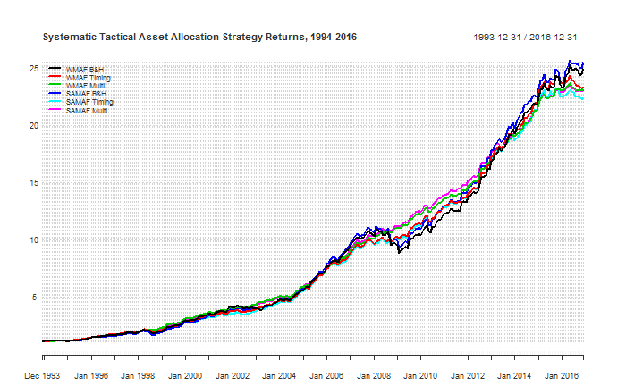

### Worldwide Multi Asset Flexible Returns

To fit within the Worldwide Mule Asset Flexible classification, the asset allocation has relative little constraints from ASISA. No minimum is set for domestic or foreign assets and they have complete flexibility in their asset allocation between and within asset class. Only CISCA regulations apply which in this case restricts commodity exposure to 10% [need to confirm this is the only constraint applicable here]. As such the following asset allocation has been selected:

* 22.5% Domestic Equity
* 22.5% Foreign Equity
* 22.5% Fixed Income
* 22.5% Property
* 10.0% Commodities

When comparing returns between the different strategies we see very strong performance from the multi strategy.

|  |  |  |  |
| --- | --- | --- | --- |
|  | WMAF B&H | WMAF Timing | WMAF Multi |
| CAGR | 14.95% | 14.63% | 14.59% |
| Volatility | 9.22% | 7.00% | 5.30% |
| Skew | -0.24 | 0.07 | 0.32 |
| Kurtosis | 2.44 | 1.82 | 0.96 |
| Inflation CAGR | 6.19% | 6.19% | 6.19% |
| % in the Market | 100.00% | 78.38% | 62.38% |
| % positive Months | 69.68% | 72.56% | 80.51% |
| Best Month | 10.33% | 9.36% | 7.28% |
| Worst Month | -12.14% | -7.75% | -2.93% |
| Max Drawdown | -18.75% | -11.52% | -2.93% |
| Max Drawdown / CAGR | 1.25 | 0.79 | 0.20 |
| Sharpe Ratio (9.84%) | 0.51 | 0.63 | 0.82 |
| Sortino Ratio | 0.90 | 1.34 | 2.21 |
| MAR Ratio | 0.80 | 1.27 | 4.99 |
| Ulcer Index | 3.77 | 1.89 | 0.72 |

### South Africa Multi Asset Flexible Returns

To fit within the South Africa Multi Asset Flexible classification, the fund must effectively invest at least 75% of their assets in South African investment markets considering a maximum of 25% of their assets can be assets outside of south Africa. [is there a commodity index or offshore equity index listed locally that counts as local?]. Combined with CISCA regulations, the following asset allocation has been selected:

* 25.0% Domestic Equity
* 15.0% Foreign Equity
* 25.0% Fixed Income
* 25.0% Property
* 10.0% Commodities

When comparing performance statistics, we see:

|  |  |  |  |
| --- | --- | --- | --- |
|  | SAMAF B&H | SAMAF Timing | SAMAF Multi |
| CAGR | 15.06% | 14.42% | 14.57% |
| Volatility | 9.22% | 7.13% | 5.36% |
| Skew | -0.30 | 0.10 | 0.41 |
| Kurtosis | 2.67 | 1.88 | 1.04 |
| Inflation CAGR | 6.19% | 6.19% | 6.19% |
| % in the Market | 100.00% | 78.79% | 0.00% |
| % positive Months | 70.40% | 72.92% | 78.70% |
| Best Month | 9.63% | 9.80% | 7.28% |
| Worst Month | -12.61% | -7.76% | -2.71% |
| Max Drawdown | -19.22% | -13.62% | -3.76% |
| Max Drawdown / CAGR | 1.28 | 0.94 | 0.26 |
| Sharpe Ratio (9.84%) | 0.52 | 0.59 | 0.81 |
| Sortino Ratio | 0.90 | 1.27 | 2.25 |
| MAR Ratio | 0.78 | 1.06 | 3.87 |
| Ulcer Index | 3.57 | 2.17 | 0.75 |

How do these compare to similar classification funds in South Africa? [get more info from peregrine/pres/seed]

Morningstar is an investment research firm that provides performance reporting of ASISA funds in South Africa. Each month they release performance figures comparing funds of the same ASISA classification. Comparing each strategy to the peers we see mixed results with some periods of outperformance and some periods of underperformance.

|  |  |  |  |  |  |  |  |
| --- | --- | --- | --- | --- | --- | --- | --- |
|  | 3m | 6m | 1yr | 3yr | 5yr | 7yr | 10yr |
| Peer Group Average | -1.41% | -1.56% | -3.75% | 7.31% | 13.95% | 12.02% | 9.74% |
| WMAF B&H | 3.93% | 0.82% | 5.80% | 8.29% | 13.42% | 13.07% | 10.59% |
| WMAF Timing | -0.41% | -4.36% | -1.25% | 5.92% | 11.42% | 10.66% | 10.63% |

|  |  |  |  |  |  |  |  |
| --- | --- | --- | --- | --- | --- | --- | --- |
|  | 3m | 6m | 1yr | 3yr | 5yr | 7yr | 10yr |
| Peer Group Average | -1.27% | -0.40% | 1.72% | 5.50% | 10.82% | 10.28% | 8.87% |
| SAMAF B&H | 3.26% | 0.92% | 6.83% | 7.94% | 12.62% | 12.62% | 10.57% |
| SAMAF Timing | -1.27% | -3.62% | -0.33% | 5.39% | 10.49% | 10.20% | 10.30% |

# Conclusion

Write when finished

# Appendix 1 – Data validity check

|  |  |  |  |  |  |  |
| --- | --- | --- | --- | --- | --- | --- |
|  | TBILLS | SP500 | EAFE | US10YR | GSCI | NAREIT |
| Return | 5.42% | 9.77% | 9.19% | 8.12% | 8.34% | 9.64% |
| Volatility | 0.95% | 15.71% | 17.60% | 8.47% | 20.55% | 18.16% |
| Sharpe (??%) | 0.00 | 0.26 | 0.20 | 0.30 | 0.13 | 0.22 |
| MaxDD | 0.00% | -50.95% | -56.40% | -15.75% | -67.65% | -68.18% |
| Inflation CAGR | 4.33% | 4.33% | 4.33% | 4.33% | 4.33% | 4.33% |

Comparing to Fabers original numbers we see these small differences: (should this be in appendix with a comment saying comfortable obtained data represents the same asset classes?)

|  |  |  |  |  |  |  |
| --- | --- | --- | --- | --- | --- | --- |
|  | TBILLS | SP500 | EAFE | US10YR | GSCI | NAREIT |
| Return | 0.01% | 0.07% | 0.02% | -0.06% | 0.02% | -0.01% |
| Volatility | 0.00% | 0.02% | -0.01% | 0.03% | 0.00% | 0.03% |
| Sharpe | 0.00 | -0.01 | -0.01 | -0.03 | -0.01 | -0.01 |
|  | 0.00% | 0.00% | 0.00% | 0.04% | 0.00% | -0.30% |
| Inflation CAGR | 0.03% | 0.03% | 0.03% | 0.03% | 0.03% | 0.03% |

Differences to fabers original research 1973-2012

Differences here to the original paper are small:

* Differences in returns <0.07%
* Differences in volatility <0.03%

Suspect this is from small differences between data providers. Comfortable using for rest of research.

# Appendix 2 – Review of R

One of the goals of this masters was to learn a new programming language R. R is an open source language widely used by data scientists for analysis in a wide variety of fields. Initiated in 1997, R has grown in popularity along with an ever increasing number of packages available that extend the base R functions.

My experience using R over the last 9 months has been mixed. Despite being relatively fluent in other programming languages and generally very competent with computers, R proved to have a very steep learning curve. Supported of R say this is an unavoidable byproduct of the languages power and flexibility however it is also related to the minimal graphical user interface and requirement to enter everything via command line. Based around S, a language written in 1970, R can be clunky and difficult to use and is code based unless you install a third party GUI. Multiple hours were spent installing R, RStudio and learning the basics and understanding the general workflow. Installing packages especially on computers with strict proxies and firewalls also soaked up time.

R has many advantages; it’s free, powerful for data analysis, open source and supported online by a large active user base. Unfortunately, one of the drawbacks to this is that support can be slow and finding solutions or debugging code can be frustrating. Support was found from a variety of sources – online forums, mailing lists, IRC chats as simply searching the internet to find solutions on sites such as stackoverflow.

One of the biggest strengths of working with R was packages. Packages are user created bundles of code, that add specialist functions to the base R code. For example all performance metrics in the report was the result of one package, with many metrics requiring a simple line of code identifying returns to calculate CAGRs, Sharpe Ratios, and max drawdowns. A summary of the packages used can be found below.

One issue I found with using packages is that updates can occur and remove previous functionality. For example the package performanceanalytics, which provides several functions for analysing portfolio performance, updated it graphs to use xyz. This resulted in several charts no longer displaying as originally designed, with simple things such as date formats no longer working to more critical things such as being unable to display on a log y axis.

There are a variety of courses available online from coursera, datacamp as well as a book R4DS that I would recommend for anyone interested in exploring R further.

Packages used:

|  |  |
| --- | --- |
| PerformanceAnalytics | Collection of econometric functions for performance and risk analysis |
| Quantmod | Charting, downloading of data from FRED, yahoo finance. |
| Quantstrat | Functions for building trading strategies |
| Dplyr / Tidyverse |  |
| Rblpapi |  |
|  |  |
|  |  |

# References

all, I. e., 2016. *Stocks, Bonds, Bills and Inflation (SBBI) Yearbook.* s.l.:s.n.

Bacon, C., 2004. *Practical Portfolio Performance Measurement and Attribution.* s.l.:s.n.

Clenow, A., 2013. *Following the Trend.* s.l.:s.n.

Covel, M. W., 2013. *Trend Following.* s.l.:s.n.

Erb, C. B. & Harvey, C. R., 2006. The Strategic and Tactical Value of Commodity Futures. *Financial Analysts Journal,* Volume 62, pp. 69-97.

Faber, M. T., 2007. A Quantitative Approach to Tactical Asset Allocation. *The Journal of Wealth Management,* Issue Spring, pp. 69-79.

Gorton, G. & Rouwenhorst, K. G., 2004. Facts and Fantasies about Commodity Futures. *Yale ICF Working Paper No. 04-20.*

Greyserman, A. & Kaminski, K., 2014. *Trend Following with Managed Futures: The Search for Crisis Alpha.* s.l.:s.n.

Ibbotson Associates, 2006. *Strategic Asset Allocation and Commodities,* s.l.: PIMCO.

Ilmanen, A., 2011. *Expected Returns: An Investor's Guide to Harvesting Market Rewards.* s.l.:s.n.

Jennings, W. W. & Payne, B. C., 2016. Fees Eat Diversification Lunch. *Financial Analysts Journal,* 72(2), pp. 31-40.

Markowitz, H., 1952. Portfolio Selection. *The Journal of Finance,* 7(1), pp. 77-91.

Martin, P. G. & McCann, B. B., 1989. *The Investor's Guide to Fidelity Funds.* s.l.:s.n.

Sandoval Jr, L. & Franca, I., 2010. *Correlation of financial markets in times of crisis,* s.l.: s.n.

Domanski, Dietrich and Heath, Alexandra (2007). Financial Investors and Commodity Markets. BIS Quarterly Review, March 2017, p. 53-67.

Faber, Meb (2006). A Quantitative Approach to Tactical Asset Allocation (working paper).

Faber, Meb (2007). A Quantitative Approach to Tactical Asset Allocation. The Journal of Wealth Management, Spring 2007, p 69-79

Ibbotson et all. 2016 Stocks, Bonds, Bills and Inflation (SBBI) Yearbook year book

Jennings, William W. and Payne, Brian C (2016). Fees Eat Diversifications Lunch. Financial Analysts Journal, Volume 72, Issue 2, p. 31-40.

Sandoval Jr, Leonidas and Franca, Italo (2010). “Correlation of financial markets in times of crisis”

Statistical Mechanics and its Applications, 391, 1, p 187-208

Inker, B., (2020). “The Hidden Risks of Risk Parity Portfolios”, GMO White Paper

Faber, Meb, A Quantitative Approach to Tactical Asset Allocation (February 1, 2013). The Journal of Wealth Management, Spring 2007 . Available at SSRN: <https://ssrn.com/abstract=962461>

Faber, M., (2007). “A Quantitative Approach to Tactical Asset Allocation”, Journal of Investing, 16, 69-79.

Ilmanen A., (2011). Expected Returns.John Wiley & Sons

Friesen, G., Weller, P. and L. Dunham, (2009), “Price trends and patterns in technical analysis: A theoretical and empirical examination”, Journal of Banking & Finance, 33, 1089- 1100.

Clare, Andrew and Seaton, James and Smith, Peter N. and Thomas, Steve, The Trend is Our Friend: Risk Parity, Momentum and Trend Following in Global Asset Allocation (July 31st, 2015). Available at SSRN: https://ssrn.com/abstract=2126478 or http://dx.doi.org/10.2139/ssrn.2126478